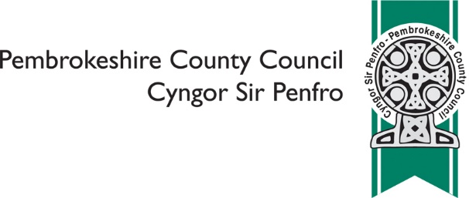

PARC GWYN CREMATORIUM – RESPONSE FORM
PROPOSAL TO INCREASE CHARGES AND IDEAS TO DEVELOP SERVICES
INCREASING CHARGES
The Council is proposing to increase a range of charges for services that are already provided at the Crematorium. These are outlined in detail in Appendix 1.
We are presenting two options:
OPTION | DESCRIPTION | ADDITIONAL POTENTIAL INCOME
OPTION 1. | An increase charges to the same level as average charges across Wales and to maintenance of charges at this level hereafter | £116,000
OPTION 2 | An increase charges to the same level as that of the nearest competitor | £239,000

Question 1. Please indicate to what extent you find Option 1 acceptable or unacceptable (please tick only one)

Acceptable Neither Unacceptable Don’t know / not sure

Question 2. Please indicate to what extent you find Option 2 acceptable or unacceptable (please tick only one)

Acceptable Neither Unacceptable Don’t know / not sure

Question 3. Please use this space to make any comments or to put forward alternatives to Option 1 and Option 2 above

IDEAS FOR DEVELOPING SERVICES
We are also exploring ideas for developing the services provided at Parc Gwyn, with the aim of improving this facility for our customers.
These include:
IDEA | DESCRIPTION
IDEA 1 | On site flower shop
IDEA 2 | On site cafe
IDEA 3 | An area in which small social functions (up to 50 people) could be held e.g. wakes, receptions, remembrance gatherings etc. One advantage of this would be that it would be possible to provide a lower cost value option
IDEA 4 | At present we are only able to offer a limited range of memorial options but would like to extend these
IDEA 5 | Alternative burials e.g. woodland burials, dedicated interment of ashes
IDEA 6 | Increasing hours and days of operation (Saturday and Sunday)
IDEA 7 | Additional car parking provision

Question 4. Please indicate to what extent you find Idea 1 acceptable or unacceptable (please tick only one)

Acceptable Neither Unacceptable Don’t know / not sure

Question 5. Please indicate to what extent you find Idea 2 acceptable or unacceptable
(please tick only one)

Acceptable Neither Unacceptable Don’t know / not sure

Question 6. Please indicate to what extent you find Idea 3 acceptable or unacceptable
(please tick only one)

Acceptable Neither Unacceptable Don’t know / not sure

Question 7. Please indicate to what extent you find Idea 4 acceptable or unacceptable
(please tick only one)

Acceptable Neither Unacceptable Don’t know / not sure

Question 8. Please indicate to what extent you find Idea 5 acceptable or unacceptable
(please tick only one)

Acceptable Neither Unacceptable Don’t know / not sure

Question 9. Please indicate to what extent you find Idea 6 acceptable or unacceptable
(please tick only one)

Acceptable Neither Unacceptable Don’t know / not sure

Question 10. Please indicate to what extent you find Idea 7 acceptable or unacceptable
(please tick only one)

Acceptable Neither Unacceptable Don’t know / not sure

Question 11. Please use this space to make any comments or to put forward other ideas

ABOUT YOU
Are you responding as (please tick all that apply)
An individual
A representative of an organisation or business (please specify) ...............................................
Other (please specify) .....................................................................................................................

For further information about why we have to ask the following questions, please see https://www.pembrokeshire.gov.uk/equalities/why-do-we-ask-equality-questions
Are you? (please tick only one)
Male Female Prefer not to say

Are you? (please tick only one)
Aged 16 or under Aged 25 – 64 Aged 75 or over
Aged 17 – 24 Aged 65 – 74 Prefer not to say

Are your day-to-day activities limited because of a health problem or disability which has lasted, or is expected to last, at least 12 months? (please tick only one)
Yes No Prefer not to say

Do you provide regular, unpaid, substantial care for a relative, friend or neighbour who is unable to manage at home without help because of sickness, age or disability? (please tick only one)
Yes No Prefer not to say

Please use this space to tell us about any other protected characteristics (e.g. ethnicity, religion, gender reassignment, sexual orientation) that you may wish to

Thank you for your time
Once complete, please scan in and email to surveys@pembrokeshire.gov.uk
You can also post to: Pembrokeshire County Council, Policy, 2D County Hall, Haverfordwest, SA61 1TP
Please return by Wednesday 31st October 2018

