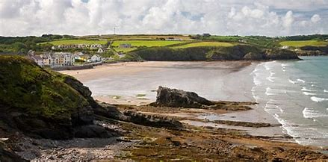
THE HAVENS COMMUNITY COUNCIL
ENVIRONMENT (WALES) ACT 2016
Section 6 BIODIVERSITY and RESILIENCE OF ECOSYSTEMS DUTY
REPORT & ACTION PLAN 2022
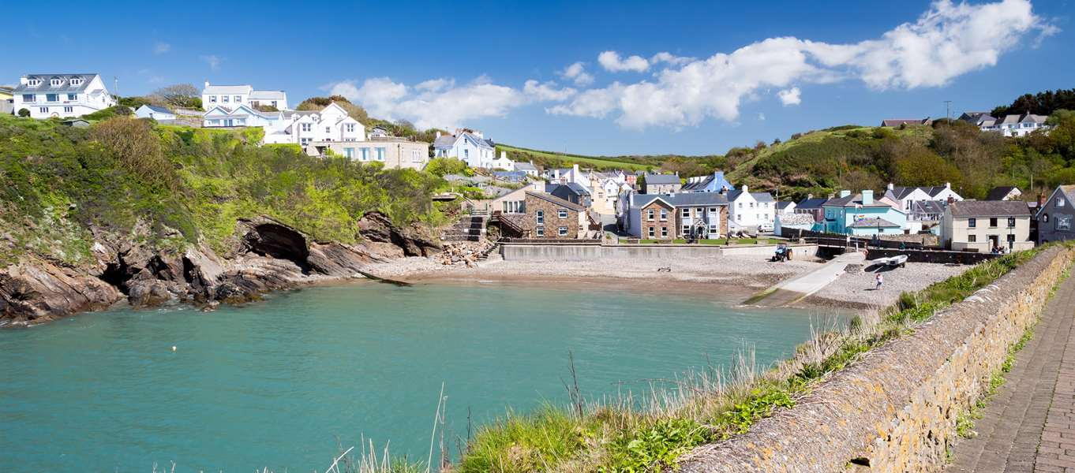
Adopted by Full Council 6th June 2023

Environment (Wales) Act 2016 Part 1 – Section 6
The Biodiversity and Resilience of Ecosystems Duty
Environment (Wales) Act 2016 Part 1 - Section 6
The Biodiversity and Resilience of Ecosystems Duty Report 2022
Name of Community Council: THE HAVENS COMMUNITY COUNCIL
Introduction and Context
The Havens Community Council (HCC) represents an area of some 18 square miles including approximately 5 miles of coastline with beach, rockpool and cliff habitats, extending approximately 2.5 miles inland at its widest point. Most land is devoted to agriculture and pasture which is bisected by streams and riparian woodland. Most of the area is within the Pembrokeshire Coast National Park. There is an electorate of just under 1,000 which is considerably expanded throughout the year with visitors. Tourism and recreation are major economic activities in holiday season. The community council precept for the year to March 2022 was £27,000.
Most terrestrial habitats of notable biodiversity value including woodland, streams, hedgerows, meadows and ponds are on private land and coastal-marine habitats are under PCNPA management. Some woodland, grassland and coastal areas at Little Haven are owned and managed by the National Trust. There are two designated SSSIs that cover the entire length of the Havens community coastline.
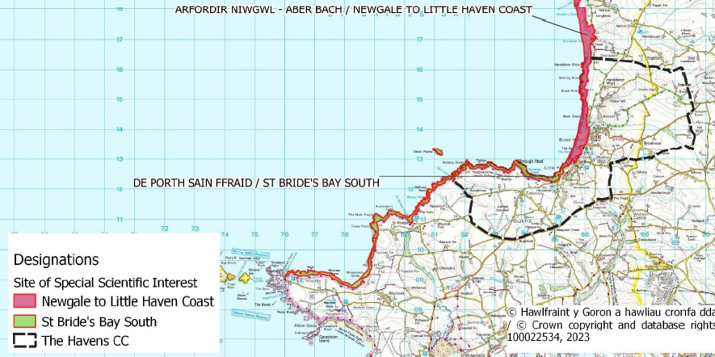
HCC directly supports significant natural habitat at Broad Haven including long term leases on an ecological corridor of riparian scrub woodland that links to the Slash Pond Community Nature Reserve. This area links across a wetland to the sea and to riparian woodland extending inland from the coast. It also has responsibility for urban green spaces in Broad Haven and Little Haven. HCC has provided regular small grant funding to a community group for management of the Slash Pond Community Nature Reserve which has enables its use for environmental education with the local school, well-being visits from neighbouring communities and counties and for provision of access to green space for the local community and visitors. It has supported litter picking events at Broad Haven beach, community tree planting, and the establishment of a marine mammal monitoring group in Little Haven. The Council is actively considering acquiring land from PCC under a community asset transfer which will be managed as an ecological corridor across the Broad Haven community. There are plans to support the maintenance of planters throughout the community as well as to fund the installation of interpretative signage at The Point in Little Haven in collaboration with the National Trust.
This is the first Biodiversity and Resilience of Ecosystems Duty Report prepared by The Haven Community Council.

Action Report 2022
(Nature Recovery Action Plan for Wales NRAP Objectives)  Action carried out to: |  | Monitored by:
1.Embed biodiversity into decision making & procurement | We have prepared the first HCC Draft Biodiversity Action Plan (Adopted June 2023 and to be reviewed May 2024) | HCC
 | As a statutory consultee, HCC will engage housing developers at the early planning stages to ensure biodiversity is considered when building new homes within the community. This action is in line with the recent Planning Policy (Wales) Act 2016 which states: "planning authorities must seek to maintain and enhance biodiversity in the exercise of their functions. This means that development should not cause any significant loss of habitats or population of species, locally or nationally and must provide a net benefit for biodiversity".
Engage and support participation and understanding to raise awareness of biodiversity & its importance | Work toward policy to procure goods and services consistent with the statutory duty to enhance biodiversity. | Chair & Clerk of the Council
 | Water quality monitoring – support NRW bathing water quality prediction model to protect Blue Flag status at Broad Haven
2.Safeguard species and habitats of principal importance and improve their management | Eradicated non-native invasive plant species (Japanese knotweed, Himalayan balsam, Winter heliotrope) from Slash Pond periphery
 | The Council has provided regular financial support to a community group that manages an area of scrub woodland, wetland, stream and pond, known as the Slash Pond as a community nature reserve with a boardwalk to facilitate access for local people and visitors and promotes environmental education.
 | Fund and collaborate with the community (especially children via Play Group) to maintain public flower boxes with native flowering plant species to support pollinators and avoid use of compost containing peat.
 | HCC, in collaboration with the National Park authority, will prepare a Nature Recovery Plan. (Draft annexed)
 | Support community initiative to acquire Haroldston Woods for use as a conservation and recreation area.
 | Identify opportunities to build connectivity between areas of high biodiversity by protecting hedges and scrub habitat between woodlands and along streams.
 | HCC is currently considering a community asset transfer of land to the eastern fringe of Broad Haven (Holbrook Road). If successful, this will transfer land management responsibilities from Pembrokeshire County Council to HCC for the management of an area of grassland, meadow and woodland that forms part of an ecological corridor connecting habitats across the community.
 | The Council is committed to fund the planting of 5 native trees in the community commemorate the Coronation of King Charles III.
 | Adopt policy to eradicate non-native invasive plant species and promote planting of native plant species.
1.Continue to provide small grant funding to the STB community group for maintenance and
2. Designate the Slash Pond a Community Nature Reserve in 2023
3.Support the creation of a reserve conservation management plan.
3.Seek to ensure compatible development in the adjacent properties in order to protect the natural habitat and water quality.
 | Offer swift and bat boxes donated by PCNPA to businesses and residents that would like one. Coordinate with PCNPA to install.
3.Increase resilience of our natural environment, restoration of degraded habitats & habitat creation | 1.Designate the Broad Haven Nature Corridor in 2023  2. Manage the area as an ecological corridor with public access.
 | Embed policy in procurement of goods and services and draft notice for all providers to ensure conformity with policy.
 | Adopt policy to manage mown green spaces to facilitate growth of flowering plants for pollinators and birdlife. Includes changing mowing regime by reducing frequency of cuts, increasing blade height and removing grass cuttings and avoid and reduce use of the most toxic herbicides including Round-Up (glyphosate).
4.Tackle key pressures on species and habitats: e.g. habitat damage and conversion, stream pollution, invasive species, waste management… | Broad Haven Christmas lights switched to LED to minimise light pollution and energy consumption 2022 | HCC
 | Identify locations of and promote removal of non-native invasive species
 | Identify opportunities to plant native shrubs and trees. Map locations.
 | Promote protection and wildlife-friendly management of hedges.
5.Use improve and share evidence, understanding and monitoring | HCC support for the STB group has facilitated engagement with WWBIC, the County Recorders, ARC and other experts to identify and monitor species diversity at the Slash Pond Community Nature Reserve. | STB & HCC
 | Adopt, document and communicate HCC biodiversity policy through various media, Community Diary, Facebook page, HCC website etc.
 | Supported establishment of a fishing gear collection point for recycling.
 | Co-fund with National Trust an interpretive natural history panel.
 | Grant fund Broad Haven Community Allotment Association to purchase water butts to capture rainfall and reduce use of well.
6.Put in place a framework of governance and support for delivery | Planned for 2023 | HCC
-support capacity and/or other organisations | Provided small grant funding for the Slash Pond Community Nature Reserve and Boardwalk since 2004 and annual ongoing. | HCC and STB group
 | HCC and Sea Trust helped support the establishment of a community marine mammal monitoring group at Little Haven.
 | Facilitate the annual Pembrokeshire Triathlon which donates to local conservation activities.
 | Plastic Free Broad Haven support
 | Adopt policy framework for embedding Biodiversity enhancement objectives in HCC policy;
Designate responsible Council member(s) for oversight.
Engage volunteers to provide support;
 | Develop collaboration with other organizations such as PCNPA to finance implementation.

Review of s6 duty
- What has worked well?
The support for the Slash Pond Community Nature Reserve and boardwalk has been a key element of the enduring success of this initiative, providing accessible green space for the mental well-being of local people and visitors and protecting important natural habitat.
- What have the barriers been?
Lack of volunteers to drive projects, possibly due to lack of clear policy guidelines.
- What will you change?
-Identify biodiversity support actions within the community for funding through the Enhancing Pembrokeshire Fund and other sources.
-Engage with PCNPA, PCC National Trust and others to access expertise and funding for implementation of the HCC Biodiversity Action Plan.
- How and when will the s6 duty be monitored and the s6 plan reviewed?
In a fixed agenda item, to monitor the s6 Duty the council will receive monthly reports from Councillors on progress or otherwise with implementation.
It is anticipated that the Draft HCC Biodiversity Action Plan will be reviewed in June 2023 and adopted immediately.

