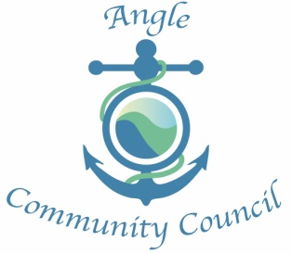
Annual Meeting
2nd May 2018 @ 18.30. Angle Village Hall

Present: Cllr A Hill(chair), Cllr B Brown (Vice Chair), Cllr D Richards, Cllr E Parker, Cllr K Bradney, Cllr S Williams, County Councillor M Bateman
Apologies:

Minutes of last AGM May 2017. Accepted and signed by Cllr Hill, Chair,

Chairs report; Attached
Treasurers Report: Attached. Audit and accounts reviewed and signed by chair

Election of Officers:
Chairperson – Cllr Shan Williams
proposed by Cllr Keith Bradney
seconded by Cllr Brian Brown

Vice Chair - Cllr Keith Bradney
proposed by Cllr Brian Brown
seconded by Cllr Eleanor Parker

Usual meeting followed.

Chairman's Report 2018

This year has been a very challenging time for us as a small community council trying to deal with what at times seems an endless amount of bureaucracy that comes through every month, In fact it actually feels like every day, and sometimes this seems to get in the way of why I, and I am sure the rest of us, became a Councillor in the first place, which certainly in my case was to do the best for this very special village and its residents in which I now have the privilege to live.

That aside I feel we have this last year made some real achievements to be proud of and as a Council we have been involved in the fight against the proposed Wind turbine development which although at the moment does seem as if we have won another battle, doesn't necessarily mean that the war is totally over quite yet. I would like to personally thank Councillor Keith Bradney for the amount of work and effort he has tirelessly put into the campaign against the turbines, being involved from the very beginning, starting the action group, and more lately as a Councillor.

We have also been able to get the remembrance plaques replaced on the front of the Village Hall with the help of the Sun Edison fund and a grant from CADW.

The Village was in danger of losing the public phone box sited in front of the Globe but as a council we managed to persuade B.T to change their mind and in fact reconnect it.

We managed to persuade the County Council to resurface the road through the village with the first part now completed and the second part plus, Shirburn Close, to be done this financial year.

And after a lot of hard work and meetings, we were finally able to get the footpath that the Village has needed for so long running from West Bay close to the beach agreed and now complete, and already in regular use which is nice to see.

These are just a few of the many things that we as a council have been involved in this year and already we are now at the start of a new campaign in which we will be at the forefront against the proposed charging at West Angle car park from the beginning of the 2019 season. But as I promised Shan I would keep this short.

There are just a couple more things I would like to say.
One is how proud I am to have been the Chair with such a great group of Councillors who all give up their time freely for the good of the Village and its residents, and who only recently showed this by unanimously voting not to accept the £150 per Year per Councillor payments which the IRPW had authorised.

And lastly I would personally like to give special thanks to Councillor Shan Williams who since resigning as clerk to become a Councillor has in fact carried on as an unpaid caretaker clerk and Councillor. Not only has she been a great help to me this year, but we as a Council would have struggled to carry on without all the many hours of unpaid work she has done on our behalf.

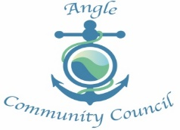
Financial Report 2017-2018.
This year ACC increased its precept to cover the additional cost of paying a clerk at the National pay scale, budget for internal audit services and general increase in overall costs. However, unfortunately we have been unable to recruit to the clerk post. With the acknowledgment that a clerk must be registered with PAYE, this has brought additional responsibilities for the Community Council. This together with the increasing work load may deter candidates.
The end of year accounts are healthy, but to highlight the potential impact of not increasing the precept last year and adjusting the accounts to reflect the status quo, ACC would have a balance of £430.00 +/- . The reducing end of year balance was highlighted last year. This is unsustainable.
With the increasing demands on Community Councils the IRP produced guidance on expense payments which had to be included in the budgeting for 2018-2019. This added an additional £900 to the precept. In addition to this we have been informed by PCC that we will be charged for election cost. This level of charge will depend on whether we have a contested election or not and could amount to £3,500.00.
This year’s Audit will be asking about reserves, which ACC has never held. However, on the basis of the above I suggest that we have a reserve account and using some of the unspent budget for 2017-2018, transfer funds in order to protect us from any unsuspecting future costs.
There has been very little call for funds from the Sun Edison fund over the past year. The balance of which is greater than end of Year for 2017 due to CADW Grant payment

