Penally Warm Wednesday | 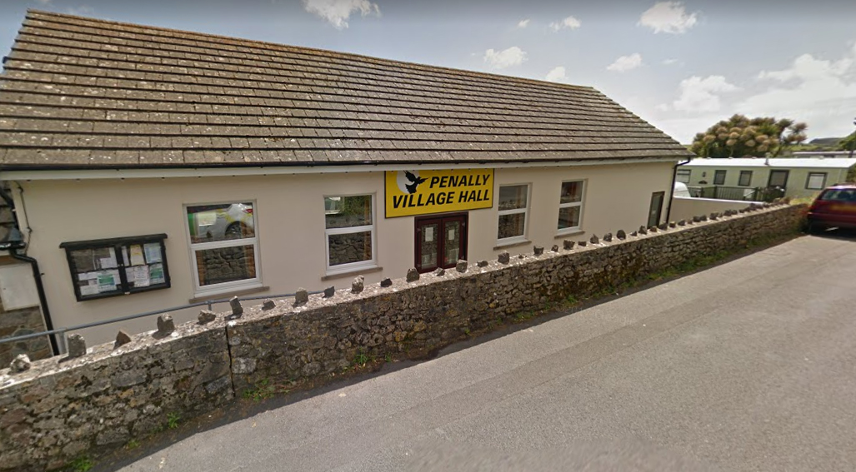

  - Penally Village Hall
  - Wednesdays 2-4pm
The village hall will be open every Wednesday between 2-4pm during the winter for anyone wishing to take advantage of a free, warm space; perhaps to read a newspaper or book in peace; or to pop in and have a cup of tea and chat with your local community councillors. We look forward to seeing you there!
Keep Warm Keep Well in Pembrokeshire

