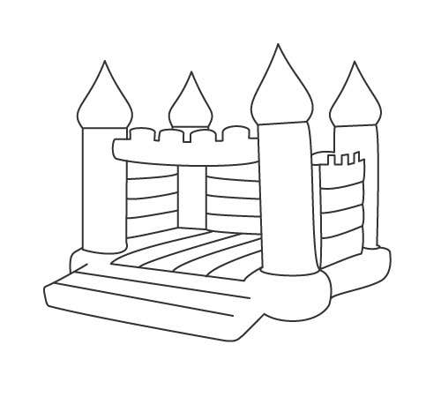

Cyngor Cymunedol Dinas Cross Community Council

Band, Bwyd a Castell Bownsio
Band, food and Bouncy Castle

Yr Hen Ysgol
Dydd Sadwrn Mehefin 4/ Saturday June 4
4yh/pm ymlaen/onwards
Bring your own drinks/dewch a diod eich hun

Croeso i bawb/ A warm welcome to everyone

