Annual Report for Llanddewi Velfrey Community Council 2022-23
Background
Llanddewi Velfrey Community Council is the tier of local government that is closest to the communities and people that it serves, and it is focussed specifically on the interests and concerns of the people who live or work in the Llanddewi Velfrey area including the various farms and businesses.
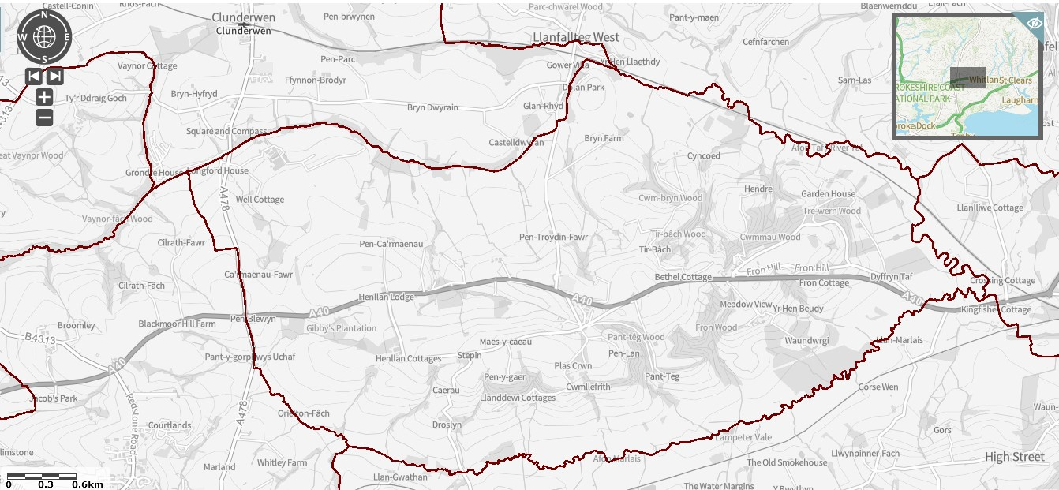
The Council is composed of six Councillors. These are elected to that position every five years by people in Llanddewi Velfrey. The Council works closely with the thriving Village Hall Committee. The Council has one part-time employee, the Clerk / Responsible Financial Officer.
The Council owns the bus shelter on the north side of the A40 close to the War Memorial, and also holds a bequest provided for the upkeep and maintenance of the War Memorial itself. The actual War Memorial is on land owned by Pembrokeshire County Council.
Priorities
Our priorities are to support the people we serve and to enhance the area in which they live and work. To do this we work with other bodies such as Pembrokeshire County Council, Pembrokeshire Association of Voluntary Services, PLANED and the aforementioned Village Hall Committee.
The Council has neither the resources nor the legal ability to cover or manage everything that it is asked to do, and as the local Council we are sometimes expected to deal with things which are actually the responsibility of another body. We do our best though! Examples include fixing broken streetlights, sorting out potholes or road damage, or dealing with fly-tipping. When this happens, the request is passed on to the relevant body, and we will let you know.
We are always open to new ideas of how we can support and help you, and assure you we will do what we can, so please do get in touch via the Clerk – contact details at the end.

Activities and Achievements
The Council, as part of its long standing support of the Village Hall and in recognition of its key importance as a central focus for the community, annually makes a donation to the Hall to cover the full cost of its insurance and also cover the required play area inspection regime and grass cutting, which ensures the equipment is safe to use and the whole area is attractive for all users.
The Council also co-ordinates the annual Remembrance service in November, and provides a wreath, donating to the Royal British Legion. 2022 marked 100 years since the War Memorial was put in place, and as a Council we supported the celebration tea that was held in the Hall.
Biodiversity
The Council recognises the importance of improving the natural biodiversity of the area, indeed of the whole country, and works to positively support such initiatives. We were therefore delighted to support the planting of a tree to commemorate Queen Elizabeth’s Jubilee behind the Hall in the play area.
The A40 Bypass
We as a Council campaigned long and hard (for decades!) for the bypass to happen, and are delighted that the project is now finally underway. We are in regular contact with the contractors Alun Griffiths, and the Clerk and various Councillors attend the quarterly Liaison Group meetings with them to get updates on progress and any issues, and to ensure any concerns about the impact the work is having upon the local community are made known so that problems can be dealt with as quickly as possible. Information is made available from them using their official website https://gov.wales/a40-llanddewi-velfrey-redstone-cross-improvements as well as with periodic newsletters that they distribute. It is also worth checking the Llanddewi Velfrey Facebook page https://www.facebook.com/groups/666210026788789/ for information.
Looking forward
We will keep working with Alun Griffiths to ensure that the community gets some good benefits from the A40 Bypass project – as well as a quieter road through the village, of course! The contractors periodically make free firewood available, which is a real benefit in these cost-pressured times. We will continue to lobby for any other benefits that we can.
Contact details
Your Councillors are:
Keith Thomas Wynn Griffiths Tudor Eynon
Meurig James Jamie Lewis Edward Howells

David Simpson JP covers this area as part of his remit as County Councillor.
Vicky Mitchell is the Clerk/RFO for the Council – clerkllv@gmail.com

Our website is https://www.pembstcc.co.uk/llanddwei-velfrey-community-council . On it you can find out more about the history of our area, what is happening now, and also the work of the Council. If you have any queries, just get in touch.

