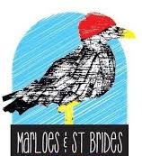
CYNGOR CYMUNED MARLOES & ST BRIDES
MARLOES & ST BRIDES COMMUNITY COUNCIL
MINUTES of Meeting of Marloes & St Brides Community Council
Monday 11th March 2024
Marloes Village Hall, 7.30pm

Clerk and Finance Officer

In attendance: Christopher Jessop (CJ), Steve Powell (SP), Peter Smithies (PS), Maren Hamre (MH), Camille Titley (CT) and Clerk; Bradley Challinor (BC)

By formal invitation: N/A

- Apologies: Louise Beal (LB)

- Declaration of Interest: N/A

- Approval of Minutes

Minutes of the meeting held at 19:30 on 08th January 2024 in Marloes Village Hall proposed and approved by Marloes and St Brides Community Council Cllr MH and seconded by Cllr CT.

Minutes of the meeting held at 15:45 on 05th February 2024 in Marloes Village Hall proposed and approved by Marloes and St Brides Community Council Cllr PS and seconded by Cllr CT.

Minutes to be scanned and electronically archived by clerk (BC).

- Community Issues

  - Broadway Fibre Broadband

No further updates.

Cllrs CJ and SP confirmed BT Open Reach advertising in the Marloes and St Brides areas for fibre broadband.

Clerk to email PCC regarding any updates on the Voneus group acquisition and finalisation of works.

  - Footpaths and Beach

Cllr CJ confirmed beach clean was a success.

CJ discussed with cllrs the increased number of cliff falls following the recent poor weather.

  - Recreation Area / Playing Fields / Village Hall

Cllr CJ confirmed the Enhancing Pembrokeshire Grant will be applied for by the Playing Field Committee and Community Council. Cllr CJ and PS have met with the fencing company to gather quotes for fencing / gates project with the playing field. Quotes outstanding.

Cllrs CJ to apply for new benches within same grant application to support action point 4.9 Village Benches.

  - Clock Tower

Cllr PS has applied for a pot of PCC funding for the broken light issue in the clock tower and Cllrs CJ and PS will organise repair.

Cllr CJ explained to cllrs the lighting requirements of the clock tower. There is no need for up lighting moving forward and clock face illumination is adequate.

  - Highways

Chair Cllr LB emailed community issues with the drains in Glebe Lane. Water has been coming through the drains. Photos were shared (please see below).
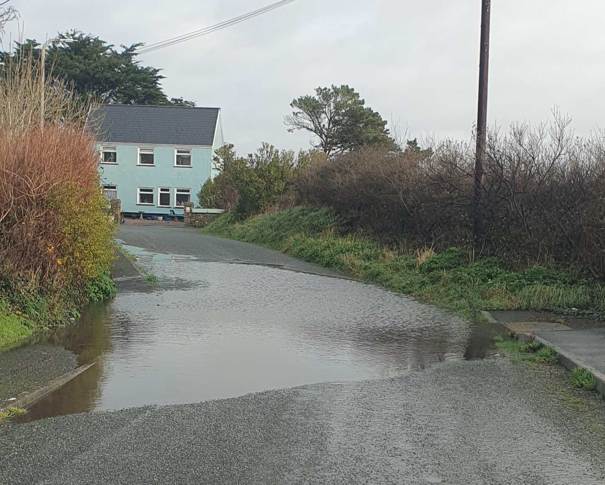

Clerk to report community issues with the drains in Glebe Lane on the PCC portal.

Cllr CJ has emailed concerns to Welsh Water (awaiting a response).

  - National Trust

National Trust parking permit afternoon was a great success. 67 parking permits issued. Thank you to the Cllrs that volunteered their time to support the National Parks and the Marloes and St Brides community.

  - Toilets
PCC have confirmed the management of the St Brides toilets will continue and be the responsibility of the National Park moving forward. Excellent news for the St Brides Community following numerous attempts from the Community Council to keep the toilet blocks open for locals and tourists.

Unfortunately the Marloes village toilets are now closed.

Cllr CJ confirmed the toilets can be removed from the community issues element of the agenda moving forward

  - St Brides Walled Garden
No updates on the St Brides Walled Garden from PCNPA. Clerk to contact PCNPA point of contact for St Brides Walled Garden and ask for an update in preparation for the next community council meeting.
Cllr SP confirmed apple trees have been planted at the St Brides Walled Garden since February 2024.

  - Village Benches
Please see action point 4.3.

  - Bus Service
Cllrs discussed the PCC bus service consultation and issues the new flexi bus service is having on the St Brides and Marloes communities and residents.
Clerk to respond to PCC regarding the outcome of the recent February 2024 council cabinet meeting regarding the Bus Service Consultation.

- Correspondence and Councillors Updates / Clerks Report

- Car Y Mor Community meeting: Cllr CJ confirmed an excellent attendance from the local community to support a healthy debate regarding the proposed new site in St Brides.

- OVW training dates have been circulated for March to Cllrs

- Clerk confirmed AGM will be held on the May Community Council meeting. Chair report for the 2023/24 FY required.

- PCC Council tax was agreed at full council for 12.5%

- Planning matters
PCNPA Development Control updates:
NP/23/0233/FUL: Marloes Mere, Marloes, Haverfordwest, Pembrokeshire, SA62 3BH. Removal of southern reservoir bunds, relocation of Public Right of Way, implementation of new southern boundary hedgerow & new causeway path at Britton Hide with new tractor gate. Approved
NP/23/0300/FUL: Harveys Cottage, Marloes, Haverfordwest, Pembrokeshire, SA62 3AZ. Flat roof rear extension to existing dwelling plus alterations to the existing internal layout. Approved
NP/23/0329/FUL: North Haven Wardens House, Skomer Island, Nr Martins Haven, Marloes, Haverfordwest, SA62 3BJ. Small extension to the exterior of the existing building to house a composting toilet. Approved
NP/23/0380/FUL: Anchor Cottage, Marloes, Haverfordwest, Pembrokeshire, SA62 3AZ. Proposed alterations, extension & cladding and retrospective permission for removal of chimney. Approved added
NP/23/0395/FUL: Winterton, Dale, Haverfordwest, Pembrokeshire, SA62 3AS. Farm diversification to convert redundant store shed to ancillary storage/plant. Approved
NP/23/0397/LBA: Winterton Farm, North Lane, Dale, Haverfordwest, Pembrokeshire, SA62 3AS. Dismantle & remove two modern farm buildings & grain silo, convert stone workshop. Approved
NP/23/0514/FUL: Anchor Cottage, Marloes, Haverfordwest, Pembrokeshire, SA62. Proposed rear ancillary gym/yoga studio. Approved
NP/23/0538/OBS: Winterton Farm, Dale, Haverfordwest, Pembrokeshire, SA62 3AS. Reconductor existing line. Response sent
NP/23/0647/FUL: Gateholm, Marloes, Haverfordwest, SA62 3BE. Two storey extensions front and rear to add additional living and bedroom space, single storey extension to create a new front entrance. Demolition of the existing garage, replaced with new timber shed. Response sent

- Financial matters

7.1 Invoices: N/A
7.2 Financial year 2023/24 and 2024/25 budget: 2023/24 FY will be finalised in April following the March 2024 bank statement. The 2024/25 draft budget has been approved and will be finalised in AGM (May 2024)

- AOB and Next Marloes & St Brides Community Council meeting date.
Next meeting: Monday 13th May 2024. Marloes Village Hall 19.30

Clerk

