THE HAVENS COMMUNITY COUNCIL

CYNGOR CYMUNED THE HAVENS
Clerk/RFO Mrs Christine Lewis, The Farmhouse, Broadway, Broad Haven, SA62 3HX Tel 01437 781418

NOTICE OF CASUAL VACANCY

Havens Community Council have a vacancy for the office of Councillor.

Any TEN local government electors for the area of The Havens Community Council may, within FOURTEEN DAYS (excluding Saturdays, Sundays and Bank Holidays) of the date of this Notice, make a written request to the Returning Officer, Electoral Services, at the following address, to hold an election to fill the vacancy.

Pembrokeshire County Council
Cherry Grove
Haverfordwest
Pembrokeshire
SA61 2NZ

If no request for an election is received within the period stated above The Havens Community Council shall fill the vacancy by co-option.

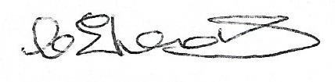
Clerk to the Council

DATE : 11 OCTOBER 2018

