WALWYNS CASTLE COMMUNITY COUNCIL

CYNGOR CYMUNED WALWYNS CASTLE
(Clerk/RFO Christine Lewis, The Farmhouse, Broadway, Broad Haven, SA62 3HX)
Tel 01437 781418 / 07970093217 Email/ebost: walwyns@btinternet.com
_______________________________________________

NOTICE OF CONCLUSION OF AUDIT FOR THE
YEAR ENDED 31 MARCH 2018
________________________________________________

Section 29 of the Public Audit (Wales) Act 2004
The Accounts and Audit (Wales) Regulations 2017
________________________________________________

The Audit of the Council's Accounts for the above year has been concluded on the 20 August 2018 by Grant Thornton UK LLP for and on behalf of the Auditor General for Wales.

A copy of the Statement of Accounts and the Auditor's Certificate and Report thereon has been published.

A local Government Elector for the Council may obtain, inspect or take a copy of the Statement of Accounts and Auditor's Certificate and report by arrangement with the Clerk at the above address, during the times set out below. Copies will be provided to any local government elector on payment of £1 for each copy of the Annual Return.

Times available: 2 pm - 4 pm, Tuesday, Wednesday and Thursday.

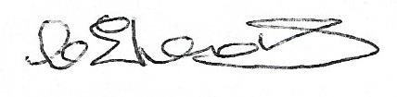
Signed on behalf of the Council .............................................................
Clerk and Responsible Financial Officer

