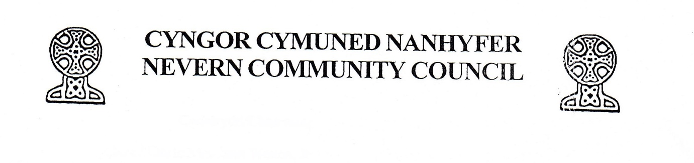
ANNUAL GENERAL MEETING/CYFARFOD CYFFREDINOL BLYNYDDOL
to be held REMOTELY/I’W GYNNAL DIOGEL
On MAY 5th 2021/Ar Mai 5^{ed} 2021
@7.30pm

If interested please contact /Os oes gennych ddiddordeb,cysylltwch â
Clerk/Clerc – Elizabeth Balchin
Email/ebost – nevernandmoylegrovecc@gmail.com
Phone/ffon - 07986354109/01239881223
AGENDA/RHAGLEN
- Members Present/Aelodau yn Bresennol
- Apologise for Absence/Ymddiheuro am Absenoldeb
- Minutes of AGM December 2020/Cofnodion y CCB Rhagfyr 2020
- Election of Chairperson and Vice Chairperson/Ethol Cadeirydd ac Is-Gadeirydd. For the period May 2021 to April 2022/Am y Cyfnod Mai 2021 hyd Ebrill 2022
- Matters Arising from AGM Minutes December 2020/Materion yn codi o gofnodion CCB Rhagfyr 2020
- Finances/Cyllid
- Any Other Business/Unrhyw Fusnes Arall

Any Other Business to be received by the clerk no later than 28th April/Unrhyw Fusnes Arall i'w dderbyn gan y clerc cyn 28 Ebrill

Clerk/Clerc – Elizabeth Balchin

