WOLFSCASTLE COMMUNITY COUNCIL

NOTICE OF CONCLUSION OF AUDIT
Accounts year ended 31 March 2020
Section 29 of the Public Audit (Wales) Act 2004
The Accounts and Audit (Wales) Regulations 2014

1.Date of Notice: 1st December 2020.
2. Notice
The Audit of the Council’s Accounts for the above year has been concluded on 20th November 2020 by Grant Thornton UK LLP for and on Behalf of the Auditor General for Wales.
3. Publication of Accounts.
A copy of the Statement of Accounts and the Auditor’s Certificate and Report thereon has been published.
4. Local Government Elector’s Rights
A Local Government Elector for the Council may obtain, inspect or take a copy of the Statement of Accounts and Auditor’s Certificate and Report by arrangement with the Clerk at the address and times set out below. Copies will be provided to any local government elector on payment of £1:00 for each copy of the Annual Return.
5. Days and times of availability
Daily by appointment (Except Saturday and Sunday) 4:00p.m. – 6:00p.m.
6. Address where the Documents may be inspected or purchased
Digwydd Paso,
Wolfscastle,
Haverfordwest
SA62 5NA
7. Signature and name of person giving Notice on behalf of Council
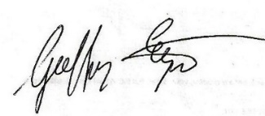Clerk and Responsible Financial Officer
This Notice is to be displayed for 14 days.

