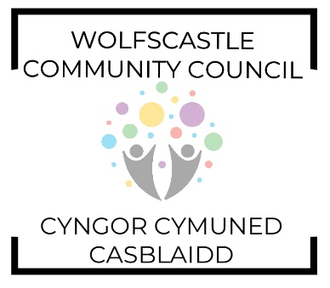
Annual General Meeting / Cyfarfod Cyfredinol Flynyddol
Followed by Monthly Community Council Meeting

AGENDA - Tuesday 14th May 2024 at 8pm. Treffgarne Village Hall.
Invitees: Cllr. Gerwyn Williams (Chairman), Cllr Peter James (Vice Chair). Cllr. Barrie Griffiths, Cllr. Brynmor Harries, Cllr. Suzanne Jenkins, Cllr Brian John, Cllr Gerallt Miles. Cllr. Michelle Bateman (PCC).

- Welcome
- Apologies
- Declarations of interest
- Confirmation of minutes 4/4/2023
- Matters arising
- Chairman’s remarks
- Treasurer’s report
- Appointment of
  - Chairman b) Vice Chair c) Signatories d) Planning sub-committee e) Internal Auditor
f) RFO
- Approval of minutes of Community Council Meeting (9-4-2024)
- Matters Arising
  - Dog Fouling signage
  - Salt Bins
  - Access Officer
  - Flag Pole
  - Litter clean
  - Car Park clean up
  - Pot Holes
  - Road closures and signs re roads unsuitable
- Correspondence
- Clerk’s update
- Planning
- Finance report
- Pembrokeshire County Council report
- Councillor’s Reports
- Date of next meeting
Members of the public are welcome to attend. Please email the Clerk for details.

