Annual Report for Llanddewi Velfrey Community Council 2021-22
Background
Llanddewi Velfrey Community Council is the tier of local government that is closest to the communities and people that it serves, and it is focussed specifically on the interests and concerns of the people who live or work in the Llanddewi Velfrey area including the various farms and businesses.
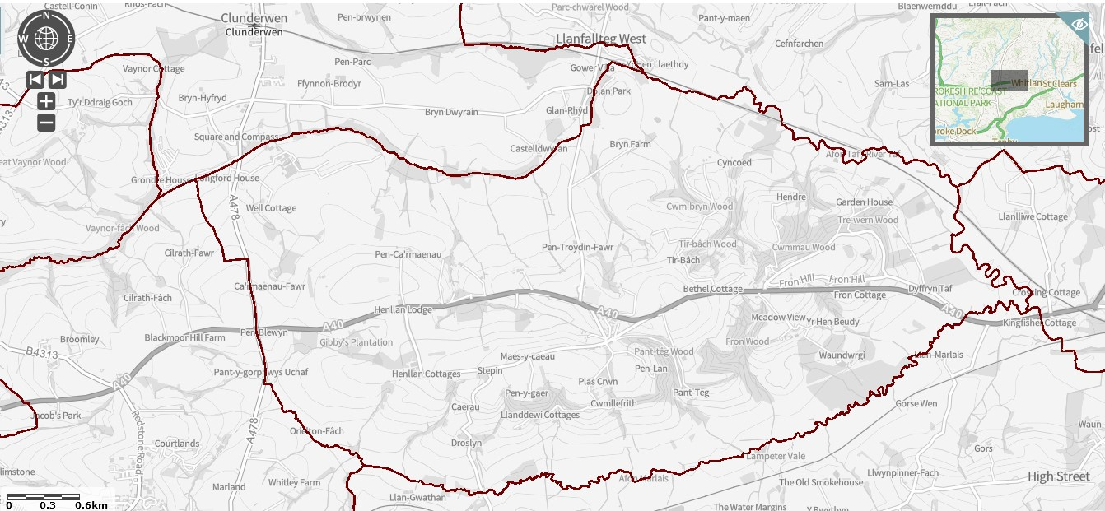
The Council is composed of six Councillors. These are elected to that position every five years by people in Llanddewi Velfrey. The Council works closely with the thriving Village Hall Committee. The Council has one part-time employee, the Clerk / Responsible Financial Officer.
The Council owns the bus shelter on the north side of the A40 close to the War Memorial, and also holds a bequest provided for the upkeep and maintenance of the War Memorial itself. The actual War Memorial is on land owned by Pembrokeshire County Council.
Priorities
Our priorities are to support the people we serve and to enhance the area in which they live and work. To do this we readily work with other bodies such as Pembrokeshire County Council, Pembrokeshire Association of Voluntary Services, PLANED and the aforementioned Village Hall Committee.
The Council has neither the resources nor the legal ability to cover or manage everything that it is asked to do, and as the local Council we are sometimes expected to deal with things which are actually the responsibility of another body. We do our best though! Examples include fixing broken streetlights, sorting out potholes or road damage, or dealing with flytipping. When this happens, the request is passed on to the relevant body, and we will let you know.
We are always open to new ideas of how we can support and help you, and assure you we will do what we can, so please do get in touch via the Clerk – contact details at the end.

Activities and Achievements
The Council, as part of its long standing support of the Village Hall and in recognition of its key importance as a central focus for the community, annually makes a donation to the Hall to cover the full cost of its insurance. We have been delighted that the Hall obtained funding for the major building works that took place in the last couple of years, and really value the improvements that have been made to the building: from the extra meeting space, the wonderful kitchen and the far better toilet facilities, the Hall is now so much better. So we are proud to be able to contribute to the ongoing support of this community building.
The Council also pays the new play area inspection and grass cutting charge that has been introduced by Pembrokeshire County Council, so that we can all be assured that the play equipment is safe to use and the whole area is kept attractive looking.
The Council also co-ordinates the annual Remembrance service in November, and provides a wreath, donating to the Royal British Legion. Normally this ceremony is held in the Hall, but as a result of covid-19 the last couple of years it has been outside at the War Memorial.

The A40 Bypass
We as a Council have campaigned long and hard (for decades!) for the bypass to happen, and are delighted that the project is now finally underway. We are in regular contact with the contractors Alun Griffiths, and the Clerk and various Councillors attend the quarterly Liaison Group meetings with them to get updates on progress and any issues. Information is made available from them using their official website https://gov.wales/a40-llanddewi-velfrey-redstone-cross-improvements as well as with periodic newsletters that they distribute. It is also worth checking the Llanddewi Velfrey Facebook page https://www.facebook.com/groups/666210026788789/ for information.

Looking forward
We look forward to the community being able to physically come together more as the covid-19 pandemic hopefully subsides – no doubt there will be many more events and gathering in the Hall, or outside on its new patio area, for instance. At the time of writing the Jubilee celebrations have just taken place, and the Council contributed a sum of money to support that amazing and incredible event – thank you to all who put so much time and effort into it.
We also keep working with Alun Griffiths to ensure that the community gets some good benefits from the A40 Bypass project – as well as a quieter road through the village, of course! In the last few months we have already negotiated the planting of a special jubilee tree, as well as the donation of free firewood for residents to collect, and we are hoping to have some improvements to the area around the War Memorial as well as parking for the two Chapels.

Contact details
Your Councillors are:
Keith Thomas
Wynn Griffiths
Tudor Eynon
Meurig James
Jamie Lewis

David Simpson JP covers this area as part of his remit as County Councillor.
Vicky Mitchell is the Clerk/RFO – clerkllv@gmail.com

Our website is https://www.pembstcc.co.uk/llanddwei-velfrey-community-council . On it you can find out more about the history of our area, what is happening now, and also the work of the Council. Any queries, just get in touch.

