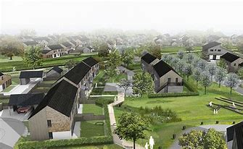

Tai Wales & West Housing Development
There will be an opportunity to view the plans and discuss the new housing development with members of Wales & West Housing Development

Wednesday 10th November
10am – 1pm
Yr Hen Ysgol

