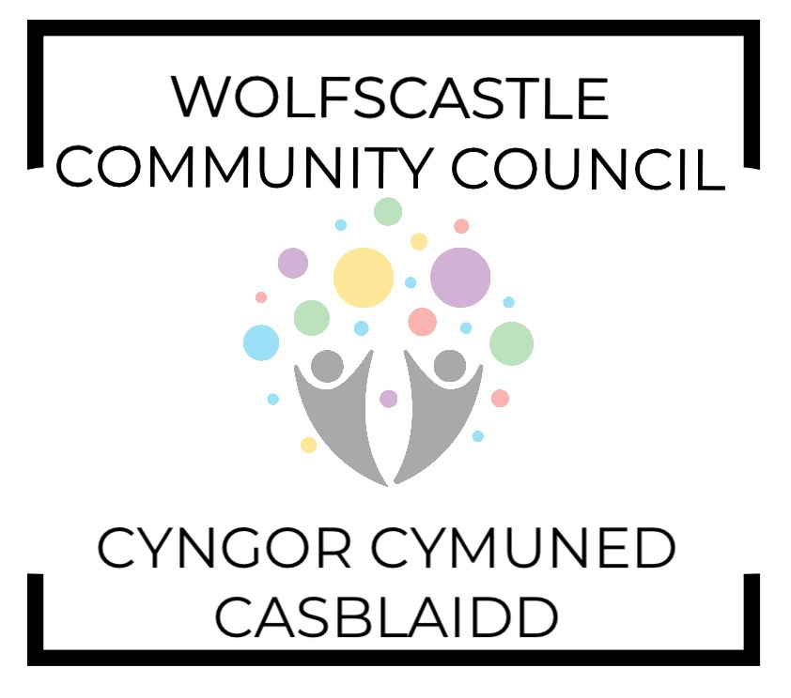
WOLFSCASTLE COMMUNITY COUNCIL
Vacancy for Clerk & Responsible Finance Officer

Wolfscastle Community Council is looking to appoint a Clerk/RFO with drive, determination, attention to detail and excellent organisational skills to manage a varied workload. You should be confident to work individually as well as be part of a team.

Holding a responsible public position, the Clerk will administer the Community Council’s affairs and act as representative and ambassador. The post holder will advise the Council in the formation of its policies and activities, produce agendas and minutes and manage the budget.

The ideal applicant will have administrative and financial experience. Prior experience of working as a Town or Community Council Clerk is not essential but any local government experience would be looked on favourably. Welsh language is desirable.

NALC Salary Point 13, currently £12.97 per hour but negotiable depending on experience and qualifications. 14 hours per month, working mainly from home but must be able to attend face to face monthly evening meetings as a minimum.

Please contact the Chairman for a full job description, if required.

To apply please send your CV and a covering letter setting out your suitability for the role to:

Cllr. Gerwyn Williams
📧 gerwynjwilliams@gmail.com
☎ 07974 748160

Closing date for applications is 5.00 pm on Friday 9th June 2023 with interviews being held the following week (TBC).
The successful candidate to take up post on the 1^{st of} July 2023, subject to references.

