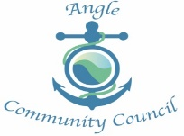

Proposed changes to the B4320/ Rhoscrowther junction – notice of meeting

Representatives from Pembrokeshire County Council will be attending ACC’s monthly meeting at 18.30 on Wednesday 4th March 2020 at Angle Village Hall to discuss the proposals to make changes to the junction leading to Rhoscrowther.

Local residents are welcome to attend this meeting to hear about the proposals first hand. If anyone would like to ask a question for PCC please submit this in writing to any Community Councillor or to anglecc.clerk@gmail.com by Friday 28th February 2020.

Anne Randall (Clerk to ACC)

