ANNUAL REPORT 2022-23

By Carol Williams, Clerk & RFO

WOLFSCASTLE

COMMUNITY COUNCIL

Table of Contents

[Table of Contents 3](#_Toc98934207)

[CONTACT DETAILS 4](#_Toc98934207)

[Town and Community Councils within Pembrokeshire County Council 5](#_Toc98934207)

[MAP OF WOLFSCASTLE PARISH COUNCIL BOUNDARIES 6](#_Toc98934207)

[CHAIRMANS OVERVIEW OF THE YEAR 7](#_Toc98934207)

[WOLFSCASTLE COMMUNITY COUNCIL AIMS AND OBJECTIVES 8](#_Toc98934207)

[Election of Councillors 9](#_Toc98934207)

[SUMMARY OF THE COUNCIL’S ACTIVITIES AND DECISIONS 10](#_Toc98934207)

[PUBLIC INVOLVEMENT 10](#_Toc98934207)

[NOTICEBOARDS 10](#_Toc98934207)

[WEBSITE 10](#_Toc98934207)

[SOCIAL MEDIA 11](#_Toc98934207)

[REPRESENTATION 11](#_Toc98934207)

[POPPY WREATHS 12](#_Toc98934207)

[CHRISTMAS TREES 12](#_Toc98934207)

[ENVIRONMENT 13](#_Toc98934207)

[VILLAGE FLOWERS AND BORDERS 14](#_Toc98934207)

[GRASS CUTTING 14](#_Toc98934207)

[ST DAVIDS DAY 15](#_Toc98934207)

[COFFEE AND CHAT 15](#_Toc98934207)

[THE DEATH OF QUEEN ELIZABETH II 15](#_Toc98934207)

[THE PLATINUM JUBILEE 16](#_Toc98934207)

[VILLAGE LITTER BIN 16](#_Toc98934207)

[LITTER PICK 17](#_Toc98934207)

[DEFIBRILATOR TRAINING 17](#_Toc98934207)

[CORONATION CELEBRATIONS 17](#_Toc98934207)

[Commemorative coins 18](#_Toc98934207)

[FINANCE 19](#_Toc98934207)

[DONATIONS 20](#_Toc98934207)

[VILLAGE IMPROVEMENT FUNDING 20](#_Toc98934207)

[CHAT BENCH 21](#_Toc98934207)

[FUNDING FOR A GAZEBO AND TABLES 21](#_Toc98934207)

[FUNDING FOR FOOD AND ELECTRICAL ITEMS 22](#_Toc98934207)

[FUNDING FOR GAMES 22](#_Toc98934207)

[GOVERNANCE AND ACCOUNTABILITY 22](#_Toc98934207)

[STAFFING 23](#_Toc98934207)

[LOOKING AHEAD TO 2023-2024 24](#_Toc98934207)

[PARISH COUNCILLOR’S CONTACT DETAILS 24](#_Toc98934207)

[APPENDIX 26](#_Toc98934207)

[1. MEETING TIMETABLE 26](#_Toc98934207)

# CONTACT DETAILS

Mrs. Carol Williams

Wolfscastle Community Council Clerk & RFO / Clerc Cyngor Cymuned Casblaidd ac RFO

Wolfscastle Manse / Y Mans

Wolfscastle / Casblaidd

Haverfordwest / Hwlfordd

Pembrokeshire / Sir Benfro

SA62 5NB

☎ 01437 741706

📱   07538 545 705

📧 [wolfscastlecommunitycouncilclerk@outlook.com](mailto:wolfscastlecommunitycouncilclerk@outlook.com)

<https://pembstcc.co.uk/wolfscastle-community-council>

Image result for facebook logoImage result for twitter logoImage result for instagram logoSee the source imageSee the source image See the source image See related image detail

# Town and Community Councils within Pembrokeshire County Council

Pembrokeshire currently has ten Town Councils, which serve the area's larger settlements, and 67 Community Councils, which serve the more rural areas.

[Town and Community Councils](http://www.pembstcc.co.uk/) serve their community by exercising a range of statutory powers and duties with the aim of improving the quality of life in their locality.

Each council is made up of elected members, or in some cases co-opted members.  Community and Town councils are responsible to their local electorates for delivering a wide range of services and for the provision and upkeep of local amenities.

We have developed a [Town and Community Council website](http://www.pembstcc.co.uk/) that brings together information about all our Town and Community Councils.  Most Town and Community Councils have listed their more recent agenda and minutes of meetings along with contact details for individual Town or Community Councillors.

[Town and Community Councils - Pembrokeshire County Council](https://www.pembrokeshire.gov.uk/town-and-community-councils)

MEETINGS

Parish Council meetings are normally held on the second Tuesday of each month at either Penybont Vestry or Treffgarne Village Hall, except for August. A meeting timetable is posted on the website (appendix1).

During the year the Community Council continued to work on behalf of the local community on a variety of issues. The volunteer Community Councillors were assisted by several other groups and individuals, notably various Pembrokeshire County Council departments.

Meetings start at 8pm, members of the public are welcome to attend although if they want to ask for information, they must submit their question at least 7 days prior to the meeting for it to be added to the agenda and for Councillors to have time to look at the information.

# MAP OF WOLFSCASTLE PARISH COUNCIL BOUNDARIES

Wolfscastle is situated in the valley of the Western Cleddau at the northern entrance to the Treffgarne Gorge. It is of equal distance with Fishguard to the north and Haverfordwest to the south on the A40. The Community area also includes the hamlets of Welsh Hook, St Dogwell and Treffgarne.

Residents of Wolfscastle and surrounding areas of which there are an estimated 708 residents have a proud community spirit which is clear to see when we come together for events such as our annual festival week, events held by Ysgol Casblaidd, Penybont and Treffgarne Owen chapels and other events coordinated by enthusiastic village groups and committees. The numerous Wales in Bloom awards and our Britain in Bloom award are proudly displayed in our village.

# CHAIRMANS OVERVIEW OF THE YEAR

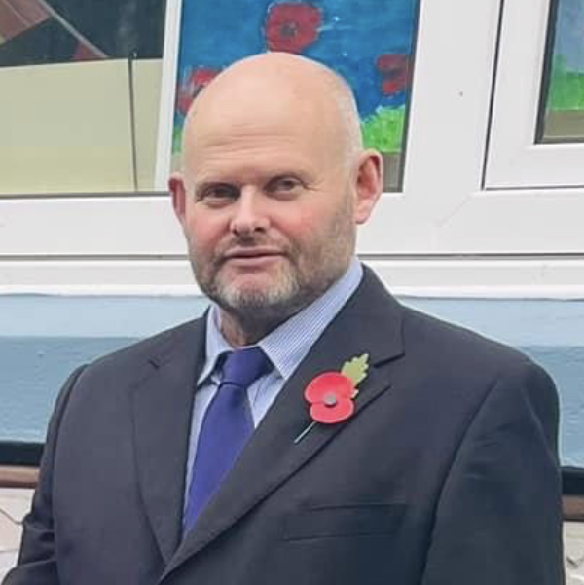

It’s hard to believe that I took the Chair in the Spring of 2022!

The first event in the calendar was the ever popular Wolfscastle Festival Week of activities and of course the Cymafa at Ford Chapel.

2022 also marked the Queen’s Platinum Jubilee. The Committee presented celebratory mugs to the children of the three parishes. Treffgarne residents gathered at Treffgarne hall where their photograph was taken by drone to mark the occasion. Sadly, Queen Elizabeth passed away peacefully on the 8th September. A Book of Condolence was opened to the community to leave their messages.

In November I attended two Remembrance Services in my role as Chair of the Community Council. Firstly, Letterston War memorial, where representatives of the local councils and other community organisations laid wreaths in memory of the fallen. The second, a service at Ysgol Casblaidd where the respect shown by the children, standing quietly to honour the many men and women who have died in conflict, was truly humbling.

As 2023 dawned we enjoyed our annual senior citizen dinner at Allt-yr-Afon Hotel [an invite list of which I am knocking on the door].

May 6th saw the Coronation of King Charles III. Our Clerk, Mrs Carol Williams, secured a very healthy £5000 grant from the Lottery Fund which paid for our celebrations. Mr Chris Wolsey, of the Wolfe Inn, and his staff could not have been more helpful. Wonderful buffets were presented at the Wolfe and packaged and transported to the Village Hall in Treffgarne. The ‘sold out’ ticket events were testament to the quality of the food and the good ‘hwyl’ of the day.

I was sceptical at the start of my year, especially as our long-standing Clerk, Rev. Geoffrey Eynon had retired, but I could not have wished for a better replacement than Carol. Her efficiency and attention to detail made my job a very easy one. Thankyou to her, my fellow councillors and the new ‘girl’ on the block, drafted in from Pontypridd.

Cllr. Gerallt Miles, Chairman (2022-2023)

# WOLFSCASTLE COMMUNITY COUNCIL AIMS AND OBJECTIVES

The Council’s key aims are:

* To act as a link between public sector organisations and the community on a range of subjects including the environment, planning, community facilities, community safety and other issues affecting the area
* To develop a picture of community needs to influence services and policies
* To represent the views of the community
* Provide a wide range of advice, information and support for the community and local voluntary groups
* Identify concerns and issues and seek to develop solutions with other partner organisations
* Support community projects and groups

# Election of Councillors

In May 2022 Councillors elected officers for the year 2022/23

They were as follows:

* Chairman: Cllr. Gerallt Miles
* Vice Chairman: Cllr. Gerwyn Williams
* Signatories: Cllr. Barrie Griffiths and Cllr. Gerallt Miles
* Planning Sub-Committee: As per area
* Internal Auditor: Mr Eric Williams
* RFO & Clerk: Mrs. Carol Williams

# SUMMARY OF THE COUNCIL’S ACTIVITIES AND DECISIONS

We have once again been busy helping and supporting our community. We have enjoyed better times this year during the post covid period, we have been able to get back to normal and meet for activities again.

## PUBLIC INVOLVEMENT

Members of the public are welcome to join us at Community Council meetings.

If you have any problems which fall within the Council’s remit, please do tell us about them and we will support you where possible.

## NOTICEBOARDS

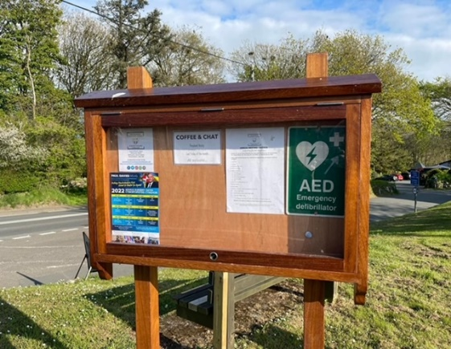

Three new notice boards were installed within our Parish this year. One in higher Wolfscastle on the corner between Ysgol Casblaidd and Wolfscastle Country Hotel, another in lower Wolfscastle opposite Penybont Chapel and a third in Treffgarne Village.

Wolfscastle and Treffgarne village noticeboards, 2023

## 

## WEBSITE

The Community Council website can be found on [Wolfscastle Community Council - Town and Community Councils (pembstcc.co.uk)](https://www.pembstcc.co.uk/wolfscastle-community-council) it has contact details, copies of approved minutes, the timetable of meetings (appendix1), details of Elections and contact details. For information on local events and initiatives, please follow us on social media.

## SOCIAL MEDIA

We have in the last year put a lot of information online including details of forthcoming events. We hope this helps members of the community be able to be more involved and that easier to approach us for support and to find out about what is going on in the Parish and County. Look for us on Facebook, Twitter, and Instagram.

Image result for facebook logoImage result for twitter logoImage result for instagram logo

## REPRESENTATION

One of the main roles of the Community Council is to make sure local views are heard by the people and organisations making decisions on issues affecting our area. One of the main areas of concern is planning. The Council considers each application and where appropriate makes comments to Pembrokeshire County Council. The final decision does not always reflect our views, but it is important local views are contributed.

## POPPY WREATHS

This year the council once again gave a donation for two poppy wreaths. One to be placed at the school Cenotaph on Remembrance Day and the other at Letterston Cenotaph on 13th November 2021. The Chairman Cllr. Gerallt Miles represented the Community at both events.

The money for the wreaths has been paid to The Royal British Legion so they can continue their good work.

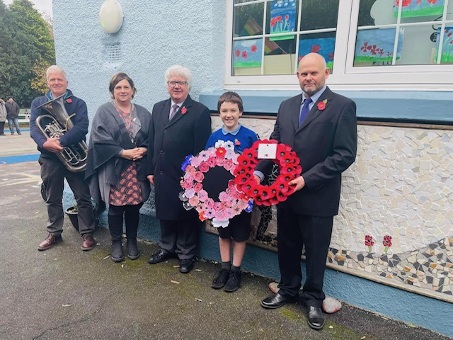

## CHRISTMAS TREES

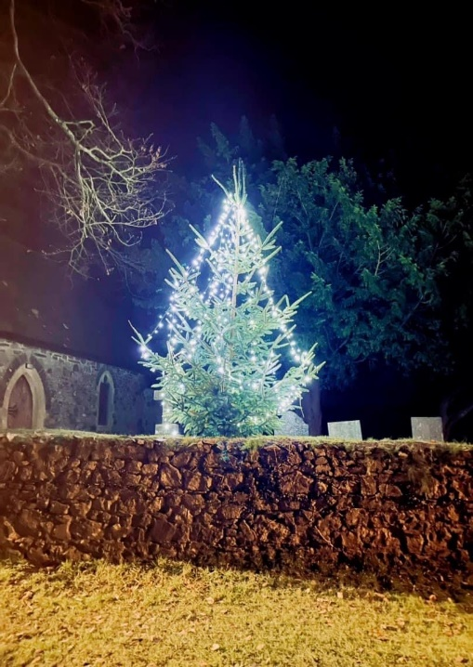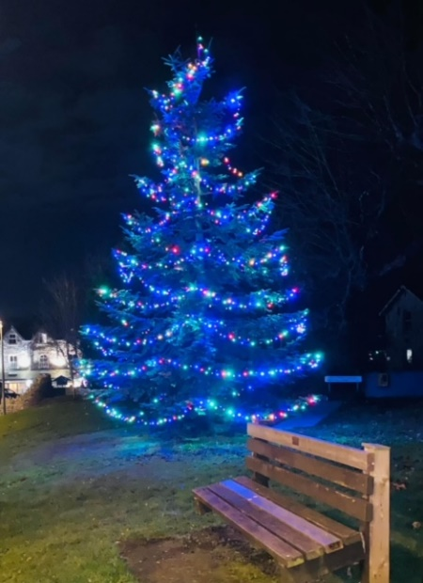Once again, we had wonderful comments on how festive the trees in Wolfscastle and Treffgarne looked. The Community Council invested in more lights for the planted tree in Wolfscastle and paid towards the tree for Treffgarne village.

We are in the process of upgrading the electricity supply at Wolfscastle, all being well, this will be in place before Christmas 2023.

Wolfscastle had a very special visitor in December which was very well received by all. Many thanks to the Fishguard Round Table for organising.

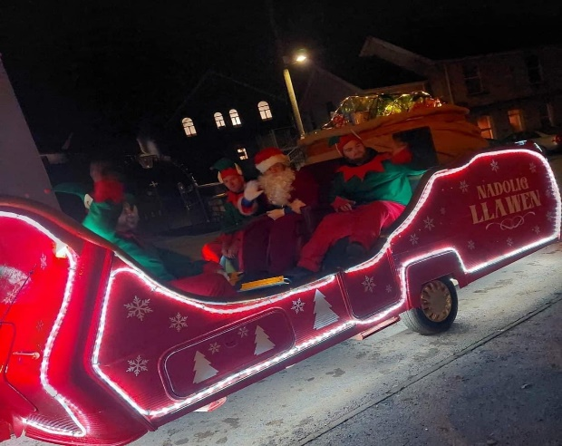

## ENVIRONMENT

Our environment is important to us within our Parish, we try our best to be as resilient and as environmentally friendly as we can.



We also have some amazing young people and residents in the village who go above and beyond to keep our village clean and tidy.

The Community Council donate to the Mathry Young Farmers Club each year and in return they kindly help us keep the village tidy by cleaning the road signs and bus shelters for which we are very grateful.

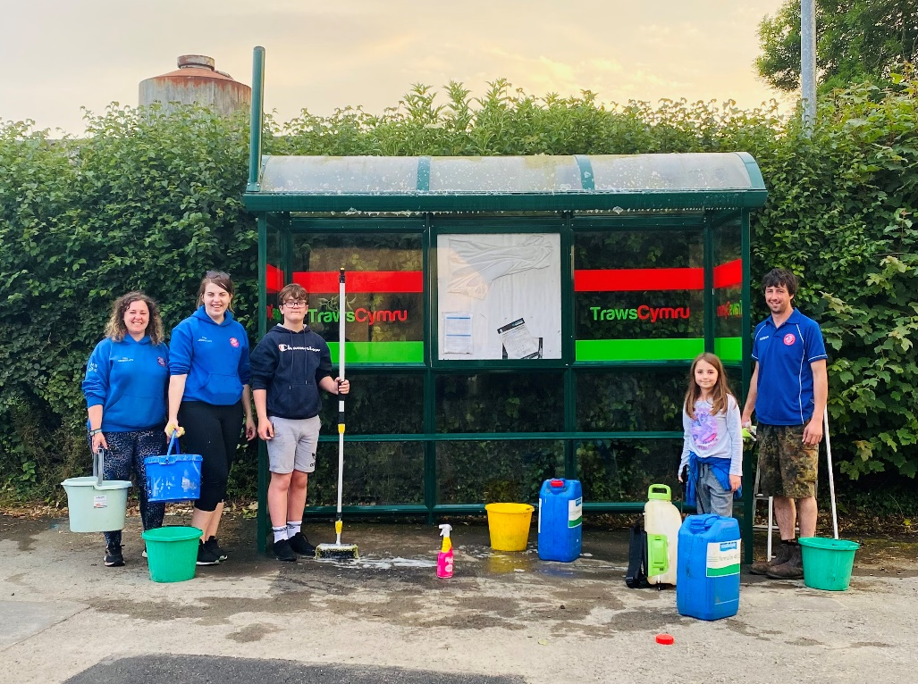

## VILLAGE FLOWERS AND BORDERS

The communities within the Parish take great pride in making our villages look pretty for villagers and visitors. Over the years we have won Wales in Bloom countless times and won Britain in Bloom which was a fantastic achievement. Although we have not taken part recently, the borders, pots and gardens are always maintained and have a fantastic show of flowers.

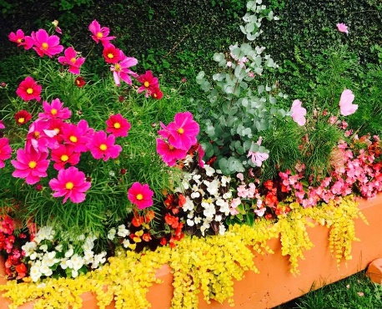The Chair and Clerk were proud to attend a special occasion in November this year to celebrate the hard work of Mr. Eric and Mrs. Gwenda Williams. Mr. John Woods, Vice Chairman of Wales in Bloom travelled down to present the Community Champions Award on behalf of RHS Wales in Bloom. There was a wonderful attendance and we all enjoyed refreshments following the presentation.

## GRASS CUTTING

Our village greens in Wolfscastle are maintained by Tim Brookes Garden Services in the summer months.

## ST DAVIDS DAY

ST David’s day is always a highlight within our community. This year we were fortunate to be able to provide the children and staff of Ysgol Casblaidd with St. David’s Day cupcakes as a treat using the Food Poverty Grant we secured. Thank you to Cllr. Suzanne Jenkins and Cllr. David Williams for presenting.

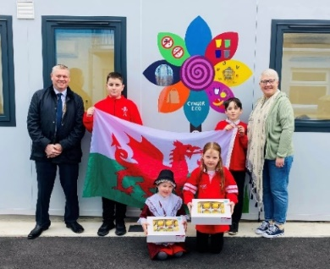

## COFFEE AND CHAT

Coffee and chat mornings are held at Penybont Vestry in Wolfscastle on Friday mornings and have been a resounding success. Members of the community have enjoyed meeting up again and having the company of friends after so many events being cancelled due to COVID-19.

## THE DEATH OF QUEEN ELIZABETH II

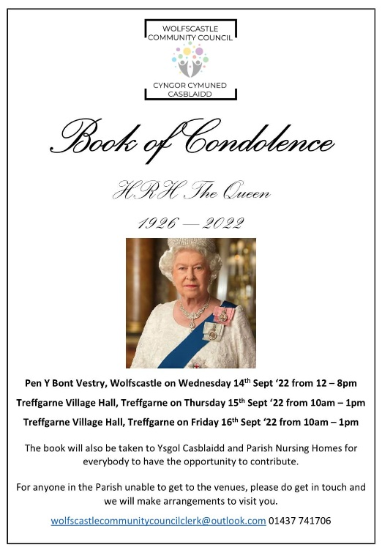We were saddened to hear of the passing of Queen Elizabeth II in 2022. In respect for the occasion, the Clerk organised a book of condolence for both Wolfscastle. Ysgol Casblaidd and Treffgarne. Everyone was welcome to write in the book which is now in archives. A letter was sent to Buckingham Palace to send sympathy and to log the book of condolence.

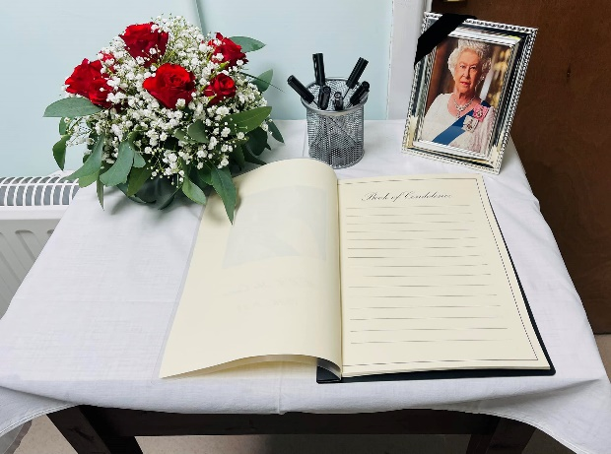

## THE PLATINUM JUBILEE

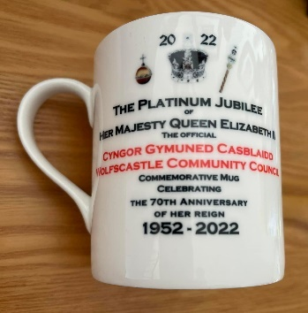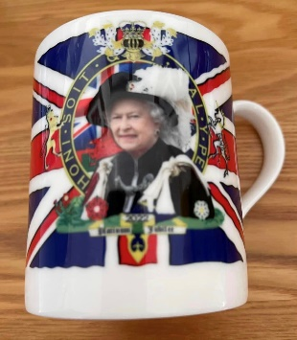The Jubilee celebrations were a highlight of the year. Everybody congregated at Ysgol Casblaidd for a wonderful afternoon tea together. It was a lovely sunny day and a good time was had by all. The Chairman and Clerk presented the children with commemorative mugs on behalf of the Community Council.

Treffgarne organised a separate village picture at Treffgarne Hall which was followed with an evening BBQ.

## VILLAGE LITTER BIN

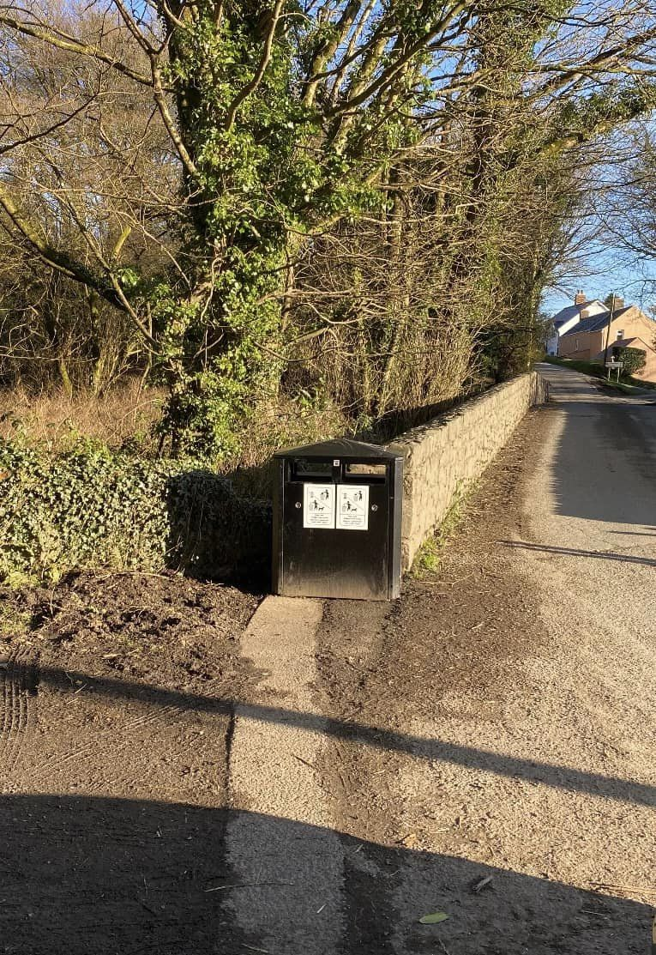Dog fouling and the littering of the bags is an issue in our parish. Thomas Goring from PCC was kind enough to supply and install a bin at the exit of Wolfscastle Woods for dog walkers to utilise. We have also enquired about a bin for Treffgarne.

## May be an image of un neu fwy o bobl a testun sy'n dweud 'WOLFSCASTLE COMMUNITY COUNCIL CYNGOR CYMUNED CASBLAIDD LITTER PICK ...keeping Wolfscastle clean and tidy... Saturday 22nd April 2023 10am at Penybont Chapel Car Park All welcome! Bags will be provided. Some equipment available. Please wear thick gloves and suitable clothing/footwear. Enquiries to Cllr. David Williams wolfsastecomutyouniderk@outloo.com'LITTER PICK

A litter pick was organised by Cllr. David Williams for April 2023. It was well attended and a lot of litter was picked. Thank you to all who attended.

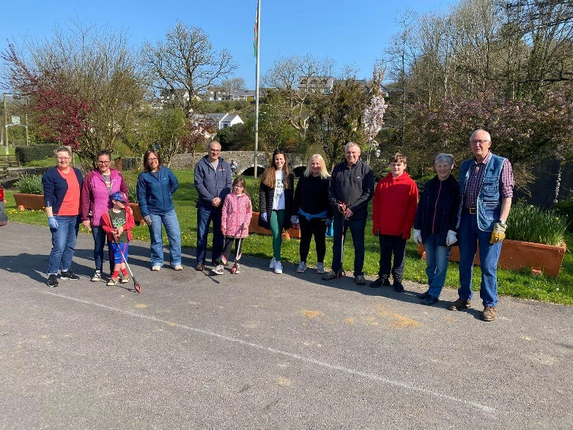

## May be an image of calon a testun sy'n dweud 'WOLFSCASTLE COMMUNITY COUNCIL CYNGOR CYMUNED CASBLAIDD DEFIBRILLATOR TRAINING HYFFORDDIANT DIFFIBRILIWR COME ALONG To LEARN NEW SKILLS OR το REFRESH YOUR KNOWLEDGE! DEWCH DRAW DDYSGU SGILIAU NEWYDD NEU LOYWI EICH GWYBODAETH! Treffgarne Village Hall Tuesday 16th May 2023 Dydd Mawrth 16 Mai 2023 7pm Penybont Vestry, Wolfscastle Tuesday 23rd May 2023 Dydd Mawrth 23 Mai 2023 7pm ALL WELCOME CROESO I BAWB FREE refreshments Lluniaeth am DDIM Enquiries/Ymholiadau: wofstecoutycuniekoulo.om'DEFIBRILATOR TRAINING

Many thanks to Tony Wall from WAST who provided us with training at Penybont Vestry and Treffgarne Hall in May 2023.

Having members of the community who are trained and confident to use the equipment is such a useful resource.

We have a defibrillator situated on the wall outside Ysgol Casblaidd, one in the telephone box library opposite Penybont Chapel and one on the wall outside Treffgarne Village Hall.

## CORONATION CELEBRATIONS

We were fortunate to be awarded a National Lottery Community Funding grant which enabled us to organise a Coronation party for the Parish. Wolfscastle held the party at The Wolfe Inn. Treffgarne wanted 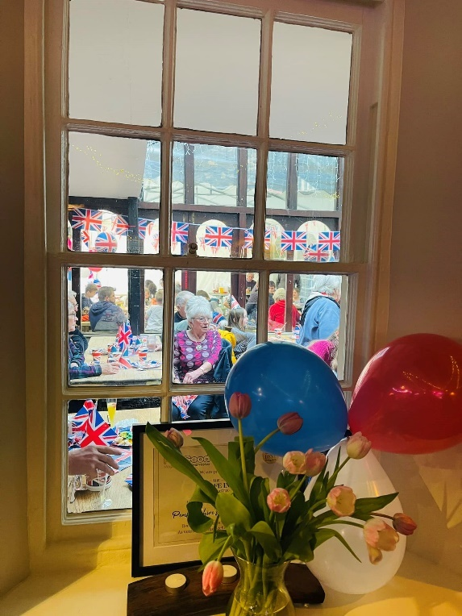to hold their own party so The Wolfe Inn kindly provided the food for their event.

Thank you to The Wolfe Inn for hosting and providing food, it was delicious and plenty of it. Everyone commented on what a fantastic occasion it was and how lovely it was to get together as a community after so long. Thank you to everyone who helped make the day special.

## Commemorative coins

As part of the Coronation celebrations, the Wolfscastle Community Council were pleased to purchase commemorative coins to give to the junior age children within the Parish.

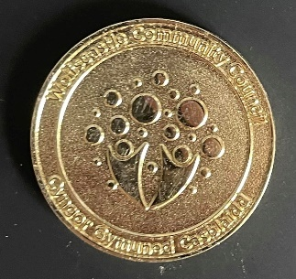

# FINANCE

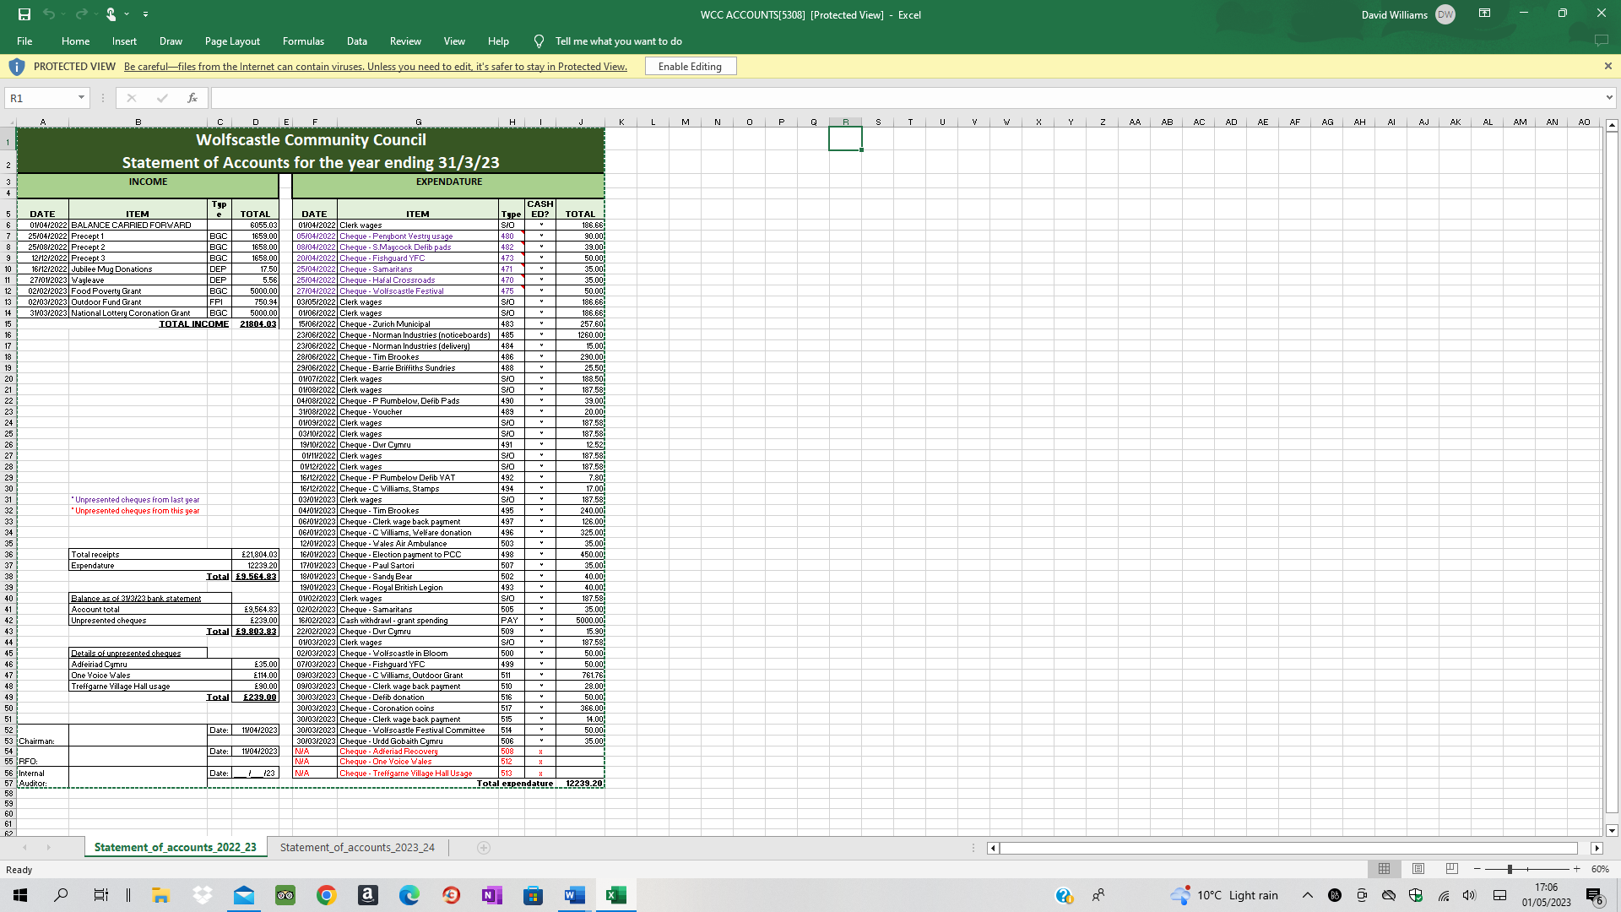

The general reserve is legally required to be maintained to cover unexpected emergencies which may arise during the year. The full Receipts & Payments Statement can be viewed on the website (published following 31st March annually) and copies are available on request.

# DONATIONS

Financial pressures have been especially hard this year due to the pandemic halting fundraising activities. Every year Wolfscastle Community Council donate funds to various charities to help them with the invaluable work they do within our communities.

This year the following charities received funds during the month of February:

|  |  |
| --- | --- |
| **Charitable Donations 2022** | |
| St Dogwell’s Welfare Committee | £325.00 |
| Wales Air Ambulance Charity | £35.00 |
| Adfeiriad Recovery | £35.00 |
| The Samaritans | £35.00 |
| Urdd Gobaith Cymru | £35.00 |
| Fishguard Young Farmers Club | £50.00 |
| Wolfscastle in Bloom Committee | £50.00 |
| Wolfscastle Festival Committee | £50.00 |
| Sandy Bear Children’s Bereavement Charity | £40.00 |
| Paul Sartori Hospice at Home  Royal British Legion | £35.00  £40.00 |

# 

# VILLAGE IMPROVEMENT FUNDING

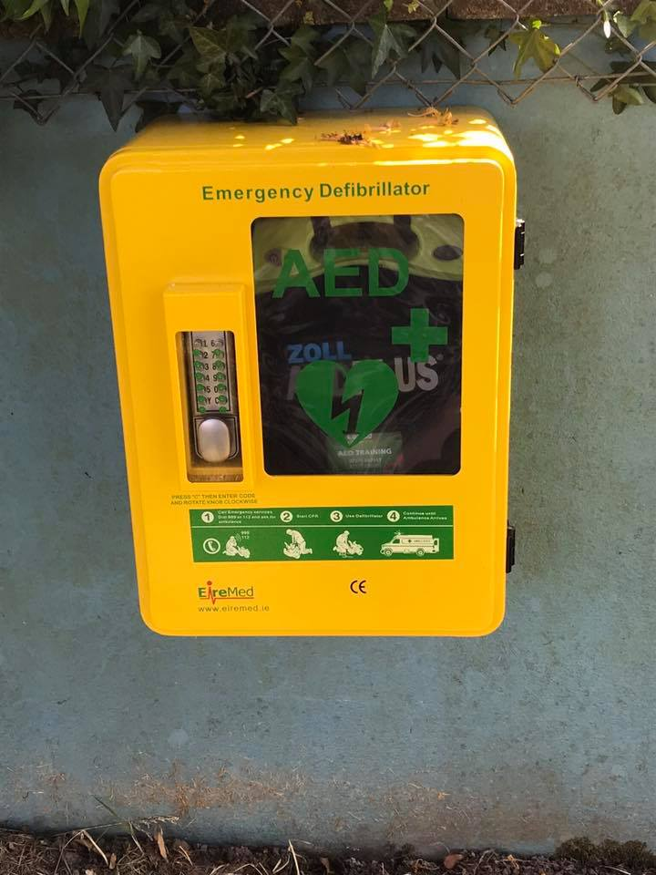The Council has continued to fund projects in the area. This year we have had a lot of funding available which we have used for good causes within the Parish.

This funding is generally used to improve the area and benefit our residents. An example of this might be the community defibrillators which we regularly pay for replacement pads and batteries as they go out of date. Mr. Steve Maycock from Wolfscastle kindly checks the equipment periodically in Wolfscastle as it is in Treffgarne.

We also pay for the Water supply to the Wolfscastle Village fountain.

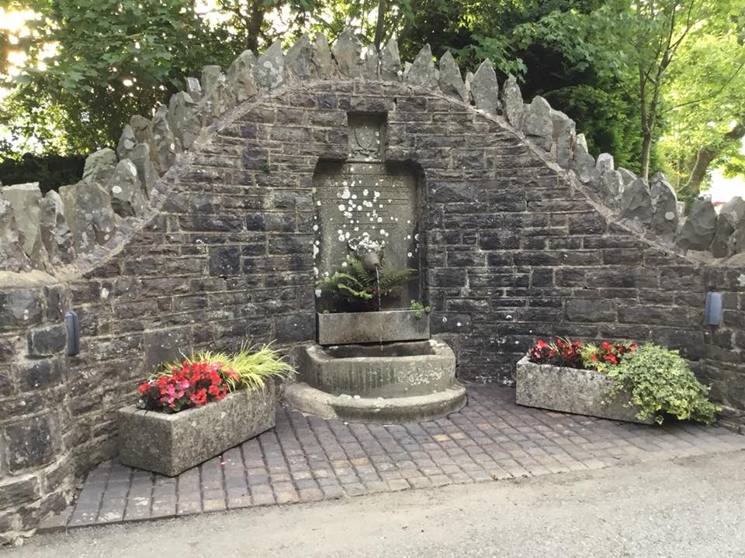

Photograph: Wolfscastle Water Fountain

# 

## Nid oes disgrifiad o'r llun ar gaelCHAT BENCH

We were delighted to receive a chat bench from Pembrokeshire County Council. The bench has been put in place on the village green in Wolfscastle for all to use. The premise is to use the bench if you are open for a chat and some company.

## FUNDING FOR A GAZEBO AND TABLES

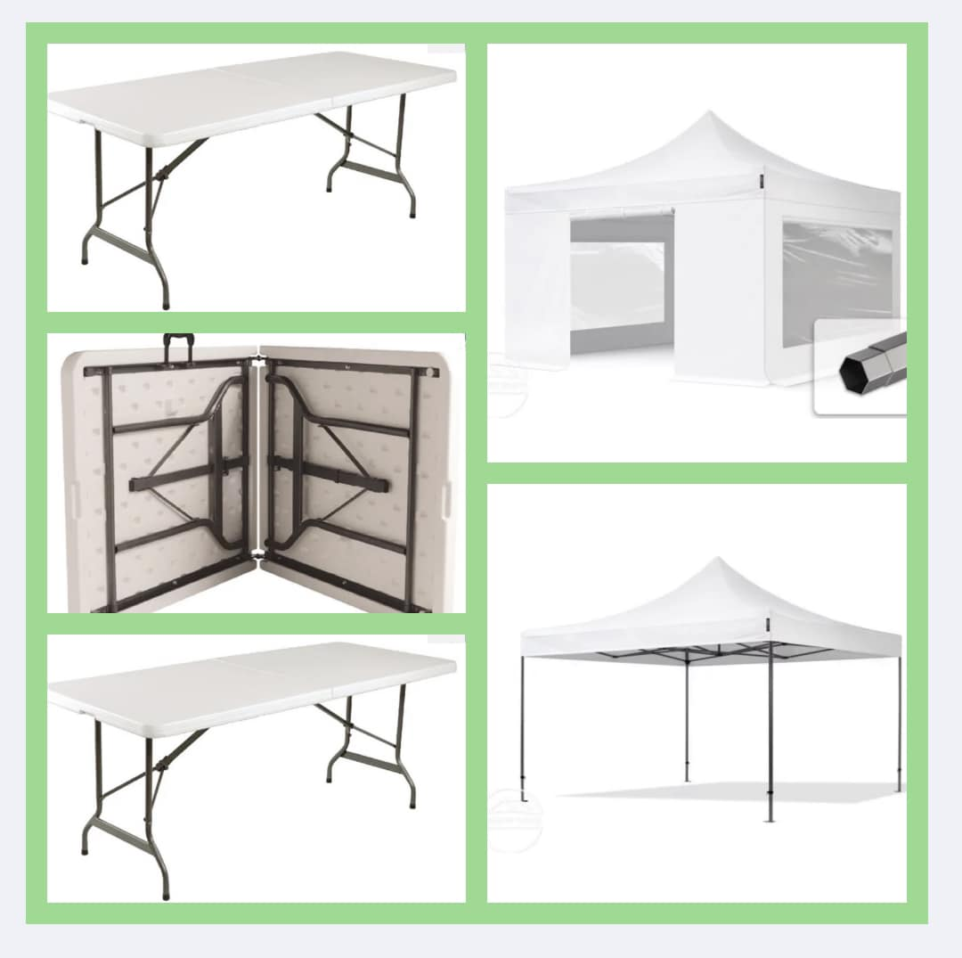Wolfscastle Community Council are delighted to be able to accept funding towards a gazebo and 3 large outdoor folding tables from the PAVS Outdoor Connections Fund grant.

This equipment will help us enormously for our fundraising efforts and community events, enabling us to provide additional shelter and seating outdoors for all.

Thank you to all involved.

## FUNDING FOR FOOD AND ELECTRICAL ITEMS

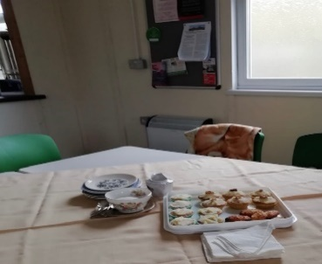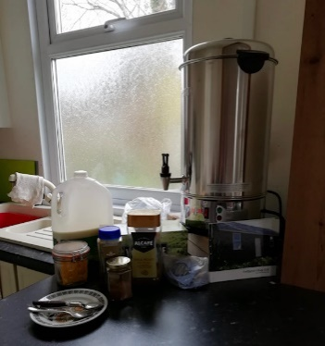We were delighted to accept this £5000.00 grant from PAVS and Pembrokeshire County Council. We were able to purchase fridge, freezer, slow cookers, toasters, toastie makers etc. plus food and consumables for all to access within our community.

The premise is that no matter your need, you can comfortably attend groups at both Penybont Vestry and Treffgarne Village Hall and whilst there receive free refreshments and/or food.

## FUNDING FOR GAMES

 We were delighted to be able to donate a variety of games and puzzles to both Penybont Vestry and Treffgarne Village Hall for members of our community to make use of. We were gifted almost £500.00.

We would like to thank South Hook LNG and PAVS for their generous contribution of funding to ensure that we can keep enriching the experiences for everybody using the facilities within our Parish. Diolch.

# GOVERNANCE AND ACCOUNTABILITY

Wolfscastle Community Council administers its own affairs effectively as evidenced both by internal and external auditing procedures.

Finances are coordinated by the Responsible Finance Officer and counter signed by two Councillors. There is no petty cash.

The Community Councils main funding for the year was from a Precept of £4,975.00.

The Council is authorised to make available a payment to each of their members of £150.00 per year for costs incurred. However, it was agreed by Councillors in May 2021 not to claim any payments for the 2022-2023 period.

Mr. Eric Williams performed our Internal Audit of accounts shortly after the year end and results were reported in the July 2022 meeting.

Council members formally approved the Annual Governance Statement for 2020/21, answering statements 1-8 in the affirmative (statement 9, regarding trust funds administered by the Community Council was completed as not applicable).

The ‘Auditor General appointed Monday, 20th September 2021 as the date from which electors could express their rights under the Public Audit (Wales) Act 2004.’ The Notice of Audit was displayed in a conspicuous place by 6 August 2021. The annual return has not been certified as yet as the audit office have delays and the paperwork has not been sent out.

# STAFFING

|  |  |
| --- | --- |
| Mrs. Carol Williams is the Clerk and Responsible Finance Officer, starting in January 2022. | |
| It is an involved role, and I am enjoying the new challenge immensely. My background is in Management, Leadership, and IT so I hope to bring some of my knowledge and experience from 20+ years Managing Clinical Audit in the NHS to this additional role. I look forward to the future, working with our dedicated Community Councillors on behalf of the community.  *Carol Williams, March 2022* |  |

# LOOKING AHEAD TO 2023-2024

2023-2024 is set to be another busy year.

It is intended that our planned work will continue to work with our objectives for the coming year. This includes working in partnership with our fellow community groups such as the Festival Committee. The Festival Week is always a well attended and received week in the calender.

Maintaining our greenspace through regular grasscutting;

Providing effective communication networks through social media and village notice boards;

Keeping defibrillators in good working order seek to ensure a safe and healthy environment;

Informing local planning and consultations, make sure our voice is heard, and;

Attending local events, such as Remembrance Sunday encourage wider community engagement.

New opportunities for fulfilling our objectives are explored through the year and reported on in the next annual review. These actions will be measured against the following:

* To support the well being of Wolfscastle and Treffgarne communities.
* To maintain a high quality and safe working, living and environment.
* To maintain a good working relationship with existing partners and identify new community partners.
* To continue to explore opportunities for community grant funding.
* To encourage community engagement and the use of effective and diverse communication methods.
* To provide transparent and sustainable community council practice.
* To provide a timely response to issues raised by the community.
* To manage all relevant planning applications and submit appropriate comment when necessary.
* Work with Local Community Police to ensure the safety and well being of the community.

# PARISH COUNCILLOR’S CONTACT DETAILS FOR 2023-2024

|  |  |
| --- | --- |
| Cllr. Gerwyn Williams (Chair)  07974 748160  [Gerwynjwilliams@gmail.com](mailto:Gerwynjwilliams@gmail.com) | Cllr. Peter James (Vice Chair)  07974 306277  [Peter.james13@btconnect.com](mailto:Peter.james13@btconnect.com) |
| Cllr. Brynmor Harries  01437 741131  [harries03@btinternet.com](mailto:harries03@btinternet.com) | Cllr. Suzanne Jenkins  01437 741113  [suzannejenkins111@gmail.com](mailto:suzannejenkins111@gmail.com) |
| Cllr. Barrie Griffiths  07974643314  [barrie.griff@btinternet.com](mailto:barrie.griff@btinternet.com) | Cllr. Gerallt Miles  01437 741203  [thomas63miles@gmail.com](mailto:thomas63miles@gmail.com) |
| Cllr. Brian John  [Bebj4198@gmail.com](mailto:Bebj4198@gmail.com) |  |

Published by: Wolfscastle Community Council

Wolfscastle Manse, Wolfscastle, Haverfordwest, Pembrokeshire, SA62 5NB

This report highlights the main achievements and activities of the Council throughout the year. Information was correct at the time of publication, please check the website for any updates.

# APPENDIX

## MEETING TIMETABLE

