FREE DEFIBRILLATOR TRAINING

The Havens Community Council, in conjunction with the British Heart Foundation (BHF) are pleased to be able to offer free training on how to use a Defibrillators (DeFib). Donations to BHF welcome.

Little Haven Village Hall
Wednesday 28 February 2024 – 6-7.30pm
Saturday 2 March 2024 – 10-11.30am

Broad Haven Village Hall
Thursday 7 March 2024 – 6-7.30pm
Saturday 9 March 2024 – 10-11.30am

Booking is ESSENTIAL, to secure your place, please email Clerk@havenscommunities.org.uk noting which venue and time you would like to attend.

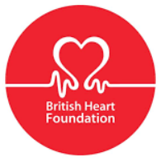

DeFib located at:
DeFib located at:
