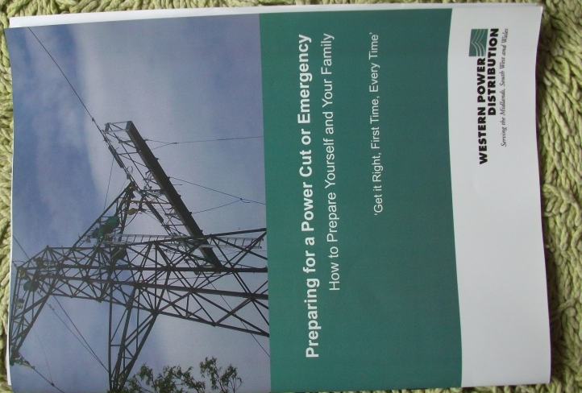
Power cuts and emergencies can occur at any time but when they happen during the cold, dark months of winter they can feel even worse.
So your Community Council along with Western Power Distribution are making a few suggestions on how you can be prepared.
The items pictured are not for sale. They are being presented as suggestions.
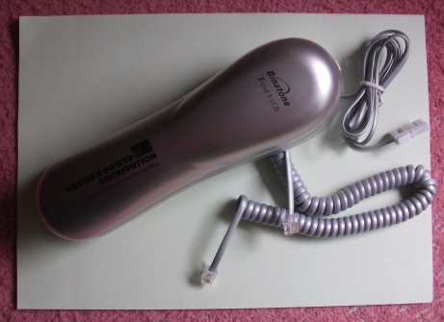
So what would be useful?

- An Analogue telephone. This only needs to be a cheap one. Digital cordless phones will not work during a power cut.

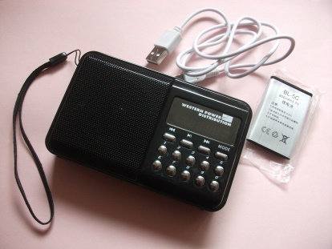
- A torch with batteries. Remember to check the state of the batteries if the torch is not used regularly. Alternatively a wind up torch, but remember to give it a good wind every couple of months otherwise the battery will not recharge if left too long.

- A rechargeable radio for listening to those all-important news updates during bad weather.

- A foil blanket. It is amazing how small the packet is but could be a life saver if the power has gone off and you have no other form of heating.

- Reusable hand warmer

- Rechargeable power pack

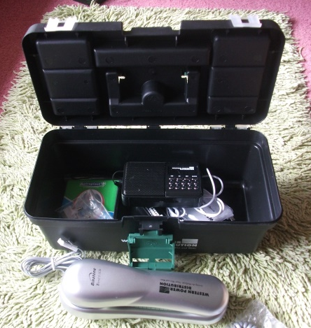
And finally a small box to keep all your emergency items in.
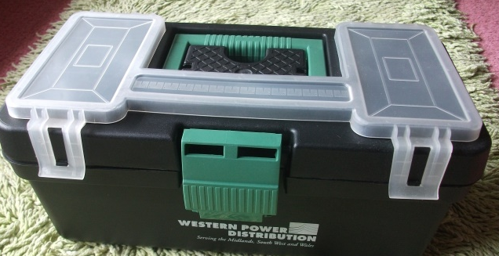

Other things you may do:
- Have a chat with your neighbours and talk about yours and their plans in the event of a power cut. Who can help out when it comes to getting a cooked meal – even if it is just beans on toast – and access to hot water using gas appliances?
- Swap telephone numbers for use if needed.
- Do you know of any vulnerable neighbours who you could help? Either by seeing they have sufficient supplies or a means of contacting friends and relatives in an emergency
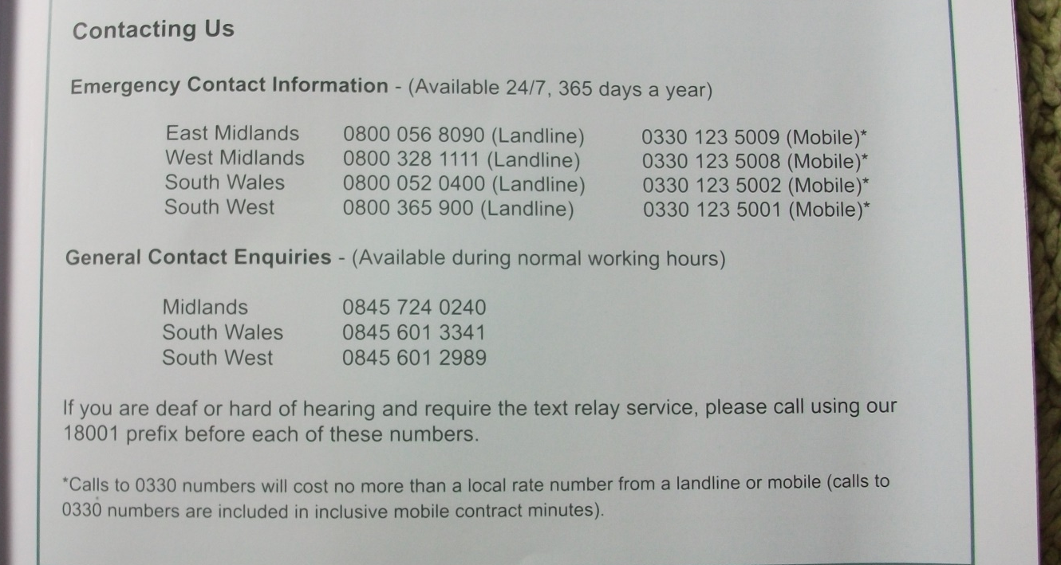
- List of emergency numbers – doctor, hospital, etc

