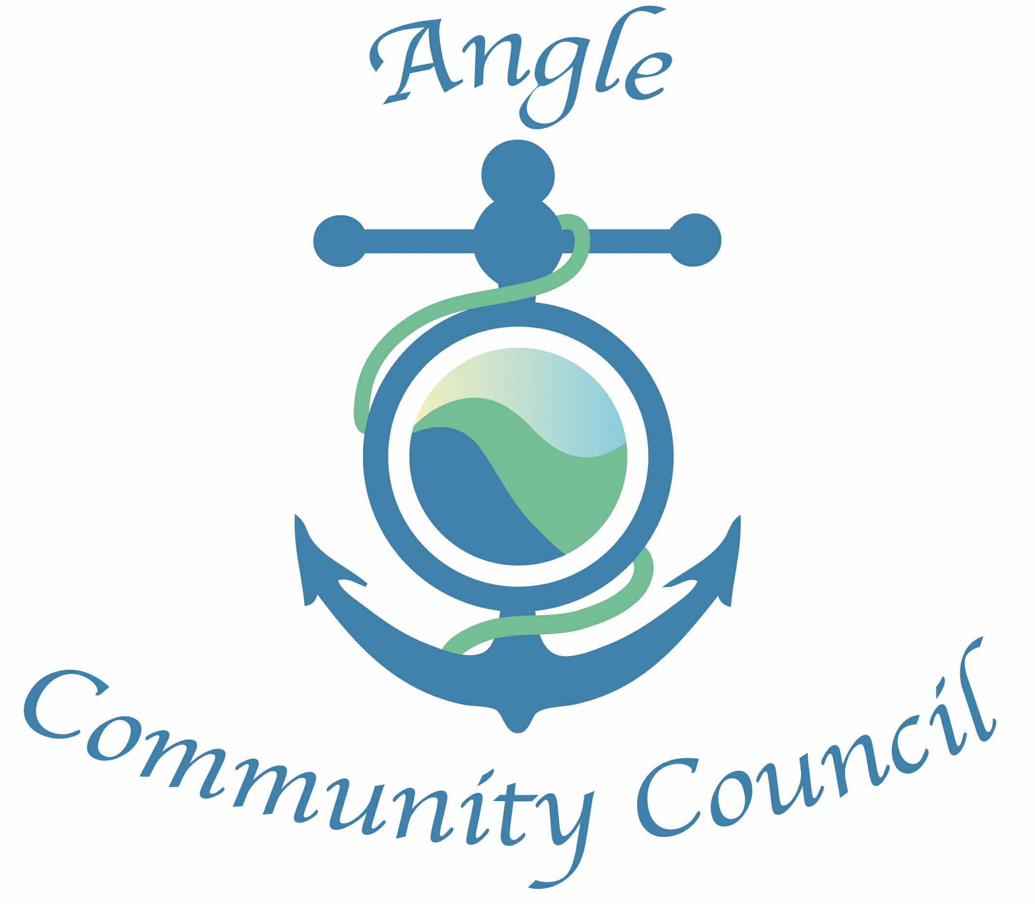

My Account – PCC engagement with local communities – notice of event for Angle residents
ACC have received the following information extracted from email from Liz Owens at PCC:
I’ve been engaged to work as a Digital Assistant with Pembrokeshire County Council, in order to support and encourage people to use alternative/digital methods of communicating with Pembrokeshire County Council – mainly via the My Account system.
The My Account has many useful features including reporting issues, applying for jobs with PCC, paying bills, checking your waste calendar, find your nearest Councillors and much more - all either at home via a computer/tablet, on a smart phone, or at a public library for anyone who doesn’t have internet at home for example.
Part of my role is to actively engage with the public at community events / groups. So if you could please bear me in mind and get in touch if you have any events coming up, or groups that could benefit from me popping along to show the features of the My Account and help people to sign up that would be great. I am hoping to join the Mobile Library on 6th February which will be going to Angle on its last stop of the day so if you know of anyone who specifically needs any assistance, please do let them know I’ll hopefully be there then. Thank you. Looking forward to hearing from you.
Thanks / Diolch
Liz
Liz Owens
CSC Assistant (Digital) / Cynorthwydd Gwasaneath i Gwsmeriaid (Digidol)
Pembroke Dock Customer Service Centre / Gwasanaeth Gwsmer Doc Penfro
Pembrokeshire County Council / Cyngor Sir Penfro
www.pembrokeshire.gov.uk/myaccount / www.sir-benfro.gov.uk/fynghyfrif

