LONG COURSE WEEKEND
PCC CORRESPONDENCE TO MARTLETWY COMMUNITY COUNCIL

Dear Clerk

Long Course Weekend 2023

As you are aware Long Course Weekend will be again hosted in Pembrokeshire (Friday 30th to June – 2nd July) this email is to provide you with an update of some of the key information.

Many of you will know that changes have been made for this year, following feedback from the 2022 event.

Road closures are primarily in place for the safety of cyclist, runners and other road users. Also, effectively with over 3000 bikes on open roads, essentially you are only driving as fast as the slowest cyclist, so the diversion routes will more than likely provide a quicker way to get to your end destination. Also, this year the organiser has linked up with “One Network”. One Network allows them to plot the closures and diversions online which the sat nav providers will feed off. This should mean that it will help people navigate around the closures. - one.network ( https://one.network/ ) (on the left hand side you will see a search bar – turn this to two weeks for your view now –

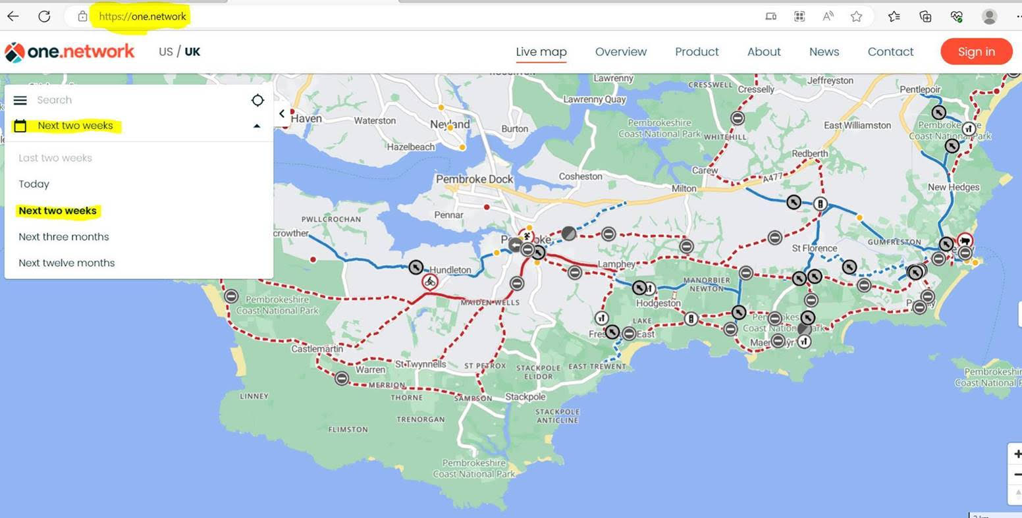

This year there will be “Hybrid Road Closure” system which has meant a reduction of up to 3 hr of road closures in some places. The hybrid closure will result in roads being opened, however, there will still be bikes on the course – tail end cyclists. . This will be carefully managed, via race control . All road closure information can be found - Long Course Weekend Road Closures (lcwwales.com)
As always, any blue light services are permitted to use the route if it’s the fastest way to get to an incident. Most services, including PCC rep, will also be in attendance in our race control room on event days.

Cares will be accommodated – link to info re carers - community.lcwwales.com/road-closures/carers-information/

If any member of your community needs to travel on the closures for emergency purposes or have any queries please contact Activity Wales on 01437 765 777 or info@activitywalesevents.com

