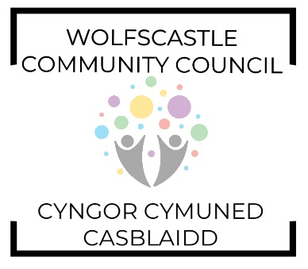
AGENDA

Tuesday 8th November 2022 at 8pm. Treffgarne Village Hall. (Please note change of venue)
Invitees: Cllr. Gerallt Miles (Chairman), Cllr. Gerwyn Williams (Vice Chairman), Cllr. Barrie Griffiths, Cllr. Brynmor Harries, Cllr. Peter James, Cllr. David Williams, Cllr. Suzanne Jenkins, Cllr. Michelle Bateman (PCC).

- Welcome
- Apologies
- Declarations of interest
- Approval of minutes 11th October 2022
- Matters arising
- Clerks update
  - WCC Timetable 2023-24
  - Training Plan
- Planning
- Finance report (RFO)
  - New Salary Scales for Clerks 22/23
- Pembrokeshire County Council report (MB)
- Councillor’s Reports (All)

Date of next meeting Tuesday 13th December 2022 at Treffgarne Village Hall.

Members of the public are welcome to attend. Please email the Clerk for details.

