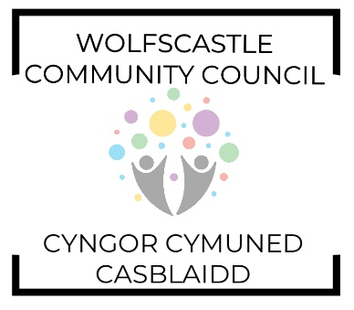
AGENDA

Tuesday 14th June 2022 at 8pm. Treffgarne Village Hall.
Invitees: Cllr. Gerallt Miles (Chairman), Cllr. Gerwyn Williams (Vice Chairman), Cllr. Barrie Griffiths, Cllr. Brynmor Harries, Cllr. Michelle Bateman (PCC).

- Welcome
- Apologies
- Declarations of interest
- Chairmans remarks
- Approval of minutes 10th May 2022
- Matters arising
- Co-opting of members
- Clerks update
- Planning
  - Planning consultation 22/0099/PA
  - Planning consultation amendment 21/0932/PA
- Finance report (RFO)
- Pembrokeshire County Council report (MB)
- Councillor’s Reports (All)

Date of next meeting Tuesday 12th July 2022 at Penybont Vestry.

Members of the public are welcome to attend. Please email the Clerk for details.

